**Lab 5 Report**

**Introduction**

This lab report discusses about the process of Lab 5, where we designed a smart doorbell system, which utilize Texas Instruments TM4C123GH6PM development board to initialize communication with smart phone android application through Bluetooth module, to detect presence of a person using ultra-sonic sensor and to display current status of the system through display expansion board as well as an Arduino Uno to drive 180-degree servo motor through PWM and Adafruit audio FX sound board to emulate 11 different doorbell tone through UART communication.

The structure of this lab report as follows:

1. Procedure
2. Implementation of UART from TM4C to Arduino Uno.
3. Implementation of Bluetooth communication.
4. Implementation of UART from Arduino Uno to Adafruit audio FX sound board.
5. Implementation of Servo motor functionality.
6. Implementation of display module and additional physical buttons.
7. Implementation of Android application.
8. Implementation of Ultrasonic senor.
9. Results
10. Problems Encountered and Feedback
11. Conclusion.
12. Appendix.
13. **Procedure**

1. Implementation of UART from TM4C to Arduino Uno.

First, I started this section by first figuring out GPIO pins and UART modules I could utilize to implement this functionality. After reading the datasheet I decided to utilize UART module 4 and GPIO Port C pin 4 and 5, where pin 4 acts as the receiver while pin 5 acts as the transmitter. After that, I decided to read the datasheet again to figure out all the registers and the value (Figure 1.1) I need to write to these registers to enable the UART functionality (**SYSCTL_RCGC2_R**, **GPIO_PORTC_AFSEL_R**, **GPIO_PORTC_DEN_R** and **GPIO_PORTC_PCTL_R**). Upon completion, I connected TM4C GPIO Port Pin 5 directly to the Arduino Uno’s RX pin (pin 0) and uploaded corresponding sketch to read data through RX 0 as well as coded TM4C to transmit data at 115200 Baud Rate. In addition, I had to use a logical level converter (Figure 1.2) to step up TM4C’s 3.3V UART signals to 5V signals such that Arduino could recognize data flowing from the TM4C microcontroller. Upon completion of above tasks, I was able to see data that was flowing to the Arduino Uno through Arduino IDE’s serial monitor.

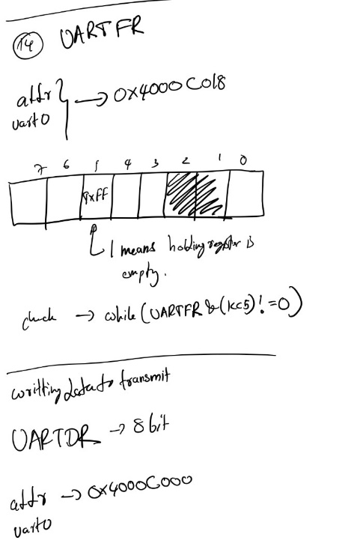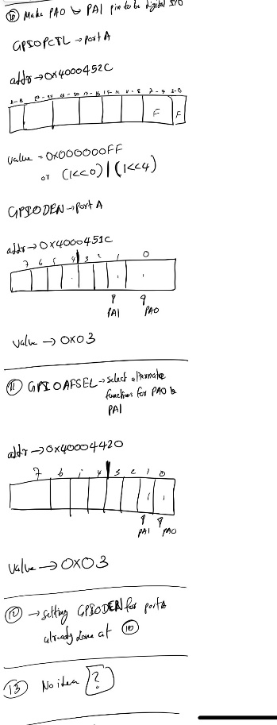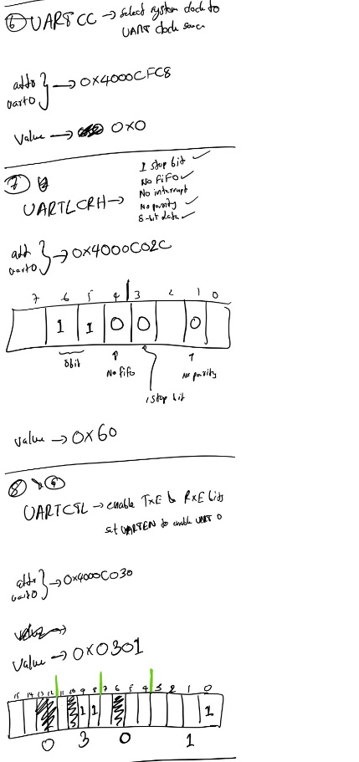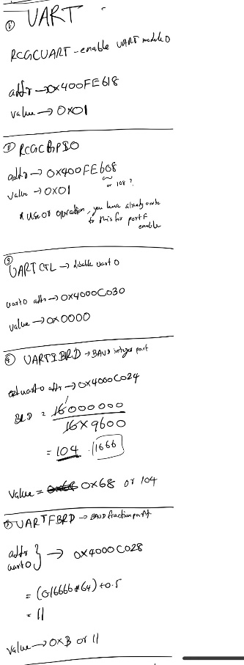

Figure 1.1

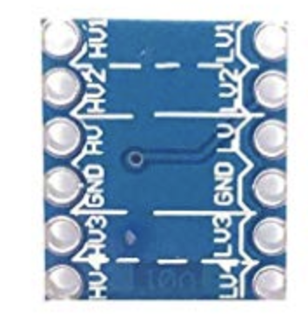

3.3V Logic Outputs

3.3V Logic Outputs

Ground

3.3V output

5V Logic Inputs

5V Logic Inputs

Ground

5V input

Figure 1.2

1. Implementation of Bluetooth communication.

Once, I figured out UART communication with the Arduino Uno, getting TM4C to communicate with Bluetooth module was easy since Bluetooth module also utilize UART communication to receive and send data to the TM4C board. Therefore, I first started by figuring out specific GPIO pins and UART module I needed to initialize the communication channel between TM4C and Bluetooth module. After reading the datasheet I decided to use UART module 3 and GPIO Port Pin 6 and 7, where pin 6 acts as the receiver and pin 7 acts as transmitter. Then I modified the code I used previously to communicate with Arduino to work with the Bluetooth module at 115200 Baud Rate. Upon completion then I decided to send character ‘a’ through Bluetooth module to test if the Bluetooth module is working properly. In order to check if my android phone can receive this data, I used “Serial Bluetooth Terminal” (Figure 1.3). Once, I started the code at TM4C I was able to see character ‘a’ on android application’s terminal.

Figure 1.3

1. Implementation of UART from Arduino Uno to Adafruit audio FX sound board.

Integrating Adafruit audio FX sound board (Figure 1.4) with Arduino Uno was a fairly easy task since Adafruit board came with a library which is compatible with Arduino Uno that can be directly used to communicate with the Adafruit sound board through software UART using Arduino Uno’s GPIO pin 5 and 6. In addition, I connected RST (reset pin) of Adafruit sound board to the GPIO pin 4 of Arduino Uno. Once, this configuration was done, I connected sound board to my computer using micro USB port on the board such that I can upload all the 11 doorbell sound effects to the board. Since, this board consist of 2x2 W built in amplifier, we directly connected pair of 2W, 8 Ohm headphone speakers to generate sound output.

Micro USB Port

Ground

3.3 – 5V input

Reset

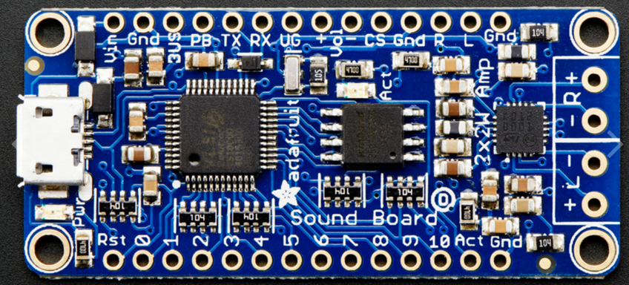

UART (TX, RX and Ground)

Physical Sound Triggers

Volume Controls

Ground

Ground

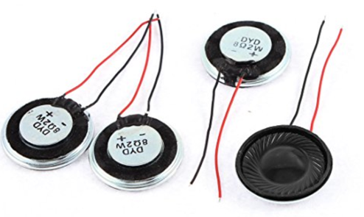

2x (2W, 8-ohm speaker connectors)

2W, 8-ohm speakers

Figure 1.4

1. Implementation of Servo motor functionality.

We decided to connect servo motor to the Arduino Uno’s PWM pin 3 since the servo motor we used only supports input signals with 5V (Figure 1.5). In addition, this servo motor is powered by 5V and GND pin outs of the Arduino Uno board. Also, we utilize “**servo.h**” Arduino library to move our servo motor 180 degrees and 0 degrees to emulate door locking and unlocking scenarios by writing data to servo motor’s data line.

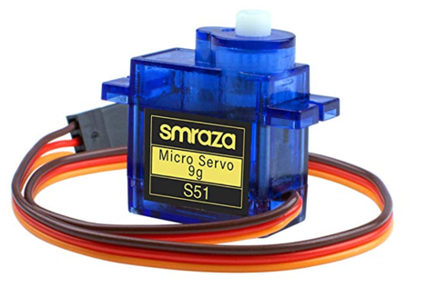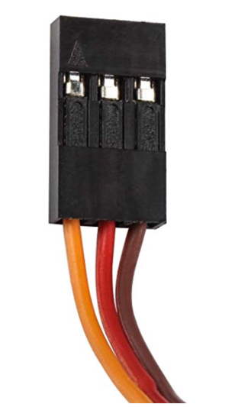

PWM control signal input

5V input

Ground

Figure 1.5

1. Implementation of display module and additional physical buttons.

We decided to use LCD display to printout current state of our system such as lock/unlock status, currently selected doorbell tone and volume of the soundboard which can be adjusted using android application. We decided not to use touch screen functionality of the LCD screen since this allows us to use GPIO Port E of TM4C board to connect physical switches. Once, LCD screen was properly connected to the Texas Instruments TM4C board we decided to reuse “**SSD2119.C**” file that we have used in Lab 4 to get the LCD screen up and running. Upon completion of this task, we decided to connect three physical switches (Figure 1.6) to a breadboard and provide them 3.3V power from TM4C 3.3V output and GND output. Then we connected switch one to GPIO Port E Pin 2 which acts as the physical button for locking the door, the second switch to GPIO Port E pin 1 which acts as the physical button to unlock the door and finally third switch to GPIO Port E pin 3, acts as the doorbell trigger. In addition, we decided to use polling to detect these button presses.

Unlock Button

Lock Button

Doorbell trigger

Figure 1.6

1. Implementation of Android application.

Once, the Bluetooth module was correctly implemented, I used Kotlin programming language to build a simple android front end (Figure 1.7) that directly connects to the Bluetooth module of the doorbell system via Bluetooth using SPP serial protocol, which has the ability to lock and unlock the door, change doorbell tone from a collection of 11 different doorbell sound effects, to increase or decrease Adafruit Sound board’s volume and finally a functionality to disconnect the app from the doorbell system.

Figure 1.7

1. Implementation of Ultrasonic senor.

//Ling’s Section

1. **Results**

Once above sub systems were implemented and tested correctly, we decided to integrate them in order to complete the system. Moreover, we implemented the logic which allows TM4C to recognize information coming from the Bluetooth module as well as from physical button and send them to Arduino Uno to execute tasks. This task was handled by the **ControllerHelper** function which constantly poll for physical button presses as well as a switch statement (Figure 2.1) that can recognize information coming from the Bluetooth module (Information to the Bluetooth module is coming from the Android application) and call **TransmitData** function which takes a character as a parameter and send this character to the Arduino Uno utilizing UART module 4 such that switch statement in Arduino Uno sketch (Figure 2.2) can recognize these characters and execute specific tasks. The following table represents characters which passed to the Arduino Uno and what they mean:

|  |  |
| --- | --- |
| Character | Meaning |
| 0 | Unlock the door |
| 1 | Lock the door |
| a | Play doorbell sound effect #1 |
| b | Play doorbell sound effect #2 |
| c | Play doorbell sound effect #3 |
| d | Play doorbell sound effect #4 |
| e | Play doorbell sound effect #5 |
| f | Play doorbell sound effect #6 |
| g | Play doorbell sound effect #7 |
| h | Play doorbell sound effect #8 |
| i | Play doorbell sound effect #9 |
| j | Play doorbell sound effect #10 |
| k | Play doorbell sound effect #11 |
| + | Increase Adafruit sound board volume |
| - | Decrease Adafruit sound board volume |

Furthermore, we implemented a function called “**AndroidToTivaController”** which constantly looks for inputs from the Ultrasonic sensor to detect any presence at the door and if so, this function will send information to Arduino Uno through UART to trigger doorbell. In addition, this function constantly calls **ControllerHelper** function in order to detect information coming from the Bluetooth module or/and physical buttons. Once, the main logic was implemented we were able to get the outcome we were looking for (Figure 2.3).

Figure 2.2

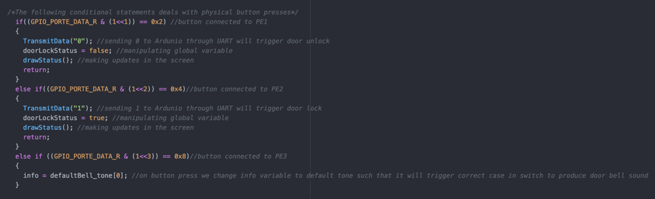

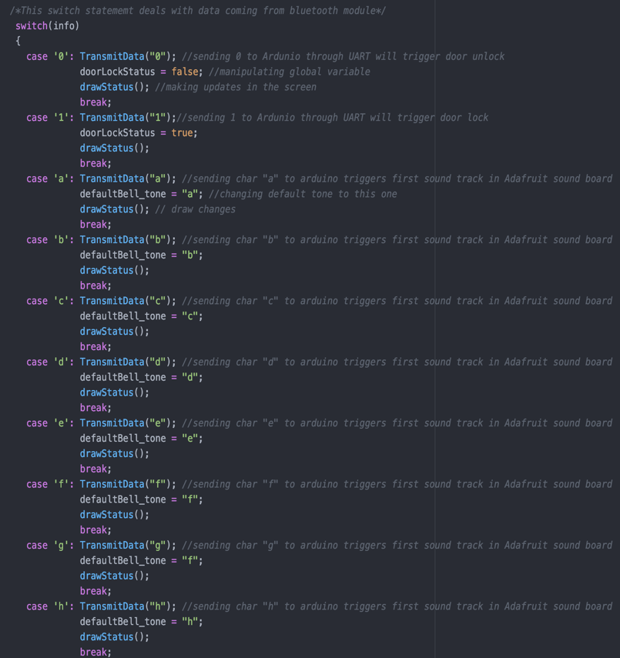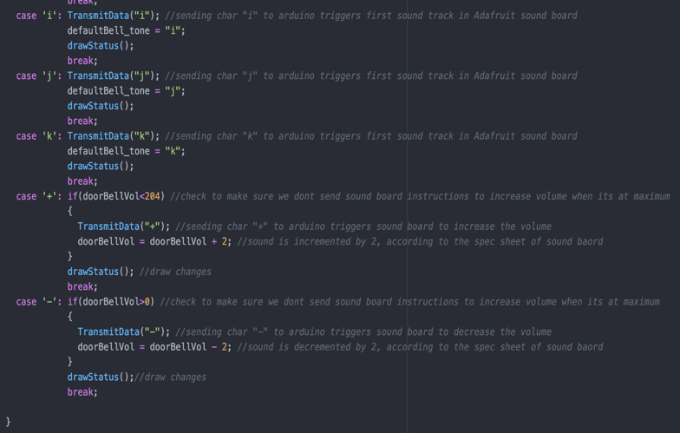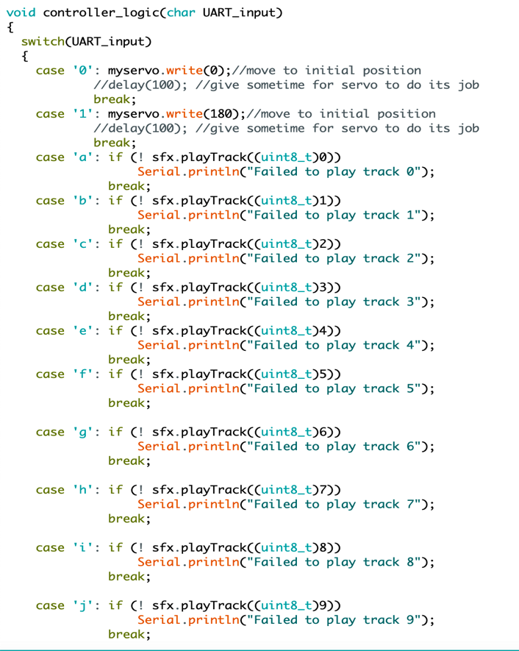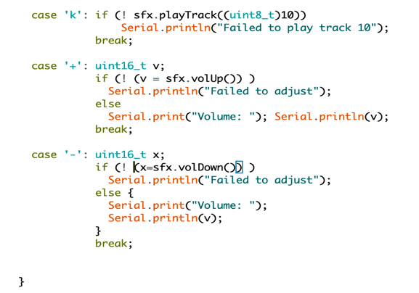

Figure 2.1

Figure 2.1

Figure 2.2

Kentec Display

TM4C123GH6PM

Arduino Uno

Lock button

Unlock button

Pair of 2W, 8-ohm speakers

Bluetooth Module

Doorbell button

Servo motor

Adafruit audio FX sound board

Ultrasonic Sensor

Figure 2.3

1. **Problems Encountered and Feedback**

One of the biggest issues that we faced was getting TM4C to send data to Arduino. We decided to use only transmission line from TM4C since our communication protocol was only one-way communication to Arduino. Therefore, first we directly connected Tx pin (GPIO Port C Pin 5) to the Rx Pin (GPIO Pin 0) of the Arduino once we completed software side of the UART communication protocol on both boards. However, once we ran the code on both boards and started serial monitor on Arduino IDE, we couldn’t see any data flowing to the Arduino. Our first guess was, Arduino Uno doesn’t support 115200 baud rate on it’s hardware UART port. Therefore, we decided to change the baud rate to 9600 on both board and gave another try and we couldn’t see any data coming to the Arduino. Therefore, we decided read Arduino Uno’s datasheet and found out Arduino Uno’s Rx pin can only recognize logic levels of 5V. Since our TM4C can only transmit logic data at 3.3V, we had figure out a way to upscale 3.3V logic to 5V logic. After days of digging information on internet, we found there’s a specialized type of circuit called “Logic Level Converters” which basically take 3.3V logic data and upscale to 5V, wise versa. Then we decided to buy couple of logic level converter from the amazon and started feeding 3.3V data line from TM4C to the logic converter and then it’s output to the Arduino Uno and then we ran the code on both development boards. To confirm the logic level converter actually scale up the logic data, we decided to use a oscilloscope to probe both ends and found out it was actually scales up 3.3V logic data from TM4C to 5V logic data. Once that was confirmed, we ran the code again on both development boards and started inspecting serial monitor on Arduino IDE and we are able to see that Arduino Uno was receiving data correctly and able to interpret data to perform different task correctly.

Other Issue that we encountered with Adafruit audio FX sound board was quite minor in comparison to the above since I accidently connected sound trigger pin on the board with a live 3.3V wire instead of ground wire to test the board to make sure it was working correctly. Therefore, I had to get a new replacement. Once, we got the new sound board we were able to see results we were expecting.

//Ling’s paragraph

1. **Conclusion**
2. **Appendix**

**TM4C code**

Main.c

1. #include <stdbool.h>
2. #include "SSD2119.c"
4. **void** intitialize_interrupts(**void**);
5. **void** initialize_timers(**void**);
6. **void** intialize_Timer0A(**void**);
7. **void** Timer_Handler_A(**void**);
8. **void** portD_Handler(**void**);
9. **void** initialize_GPIOC(**void**);
10. **void** UART4_Init(**void**);
11. **void** UART3_Init(**void**);
12. **void** delay(**void**);
13. **void** TransmitData(**char**\* data);
14. **char** readFromBluetoothModule(**void**);
15. **void** AndroidToTivaController(**void**);
16. **void** mainScreen();
17. **void** initialize_GPIOE(**void**);
18. **void** drawStatus(**void**);
19. **void** set80Mhz(**void**);
20. **void** Setup_GPIOF(**void**);
21. **void** Setup_TIMER1(**void**);
22. uint32_t measureD(**void**);
23. **void** ControllerHelper(**void**);

26. /*Varaibles needed to Ultrasonic sensor*/
27. uint32_t    pulseWidth;
28. **double**      distance;
29. uint16_t    count = 0;
31. **char**\* defaultBell_tone = "a"; //this will keep track of default door bell tone
32. **int** doorBellVol = 204; //always starts at maximum volume --> this is how sound board is default to when start, also keep track of door bell volume
33. **bool** doorLockStatus = **false**; //false -> unlocked, true-> locked
34. **int** main()
35. {
36. //initializing
37. set80Mhz();
38. LCD_Init();
39. initialize_GPIOC();
40. initialize_GPIOE();
41. Setup_GPIOF();
42. initialize_timers();
43. intitialize_interrupts();
44. Setup_TIMER1();
45. UART4_Init();
46. UART3_Init();
47. //end of initialzing
48. //when program starts we make sure it starts with door lock unlocked
49. TransmitData("0");
50. **while**(**true**)
51. {
52. mainScreen();
53. }
55. **return** 0;
56. }

59. /*This function acts as a helper function that constantly checks for any data from Bluetooth or
60. button presses and draws initial information on the screen when system is started*/
61. **void** mainScreen()
62. {
63. LCD_ColorFill(Color4[0]); //change background to black
64. LCD_DrawRect(0,0,318,180,Color4[15]);//draw a rectangle
65. drawStatus();
66. **while**(**true**)
67. {
69. AndroidToTivaController(); //calling this function infinitly, so it can detect information coming from bluetooth module
71. }
72. }
74. /*This function draws the door bell status (locked or unlocked), user selected door bell tone
75. and user selected door bell volume to the screen*/
76. **void** drawStatus(**void**)
77. {
78. //drawing dor lock status
79. LCD_SetTextColor(255,255,255); //text in white
80. LCD_SetCursor(15,192);
81. printf("Door Lock Status:");
83. LCD_SetCursor(120,192);
84. **if**(!doorLockStatus)
85. {
86. LCD_SetTextColor(0,255,0); //print in green
87. printf("Unlocked\r\n");
88. }
89. **else**
90. {
91. LCD_SetTextColor(255,0,0); //print in red
92. printf("Locked  \r\n");
93. }
95. //drawing user selcted door bell tone
96. LCD_SetCursor(15,207);
97. LCD_SetTextColor(255,255,255); //text in white
98. printf("Door Bell Tone  :");
99. LCD_SetCursor(120,207);
100. printf("             ");
101. LCD_SetCursor(120,207);
102. printf("Tone #%d\r\n",defaultBell_tone[0]-96);
104. //drawing user selected door bell volume
105. LCD_SetCursor(15,222);
106. LCD_SetTextColor(255,255,255); //text in white
107. printf("Door Bell Volume:");
108. LCD_SetCursor(120,222);
109. LCD_SetTextColor(255,255,0); //text in Yellow
110. printf("        ");
111. LCD_SetCursor(120,222);
112. printf("%d\r\n",doorBellVol);
114. }

117. /*This function will enable interrupts for the Timer OA*/
118. **void** intitialize_interrupts(**void**)
119. {
120. TIMER0_IMR_R = 0x01; //turning on Timer A Time-Out Interrupt Mask - Timer 0
121. NVIC_EN0_R = 0x00080008;  //turning interrupts on for timer0A and PORT D at 3rd position
123. }


127. /*This function bascally turns on the clock for Timer 0A and call initialize Timer 0A function to initialize
128. timer 0A to tick each second when processor clock is 16Mhz (default clock)*/
129. **void** initialize_timers(**void**)
130. {
131. SYSCTL_RCGCTIMER_R = 0x01; //enabling timer 0
132. intialize_Timer0A();
133. }
135. /*This function will configure timer 0A to be count down mode and tick each second when
136. processor clock is 16Mhz*/
137. **void** intialize_Timer0A(**void**)
138. {
139. TIMER0_CTL_R = 0x00; // disable timer for configuration
140. TIMER0_CFG_R = 0x0; //selecting 32 bit mode
141. TIMER0_TAMR_R = 0x002; // TAMR to periodic timer mode and TACDIR to count down mode
142. TIMER0_TAILR_R = 0x00F42400; //0x00F42400; // setting 16000000 --> 1Hz
143. TIMER0_CTL_R = 0x01; //finally enabling the timer
144. }

147. /*Interrupt handler for timer 0A */
148. **void** Timer_Handler_A(**void**)
149. {
151. **if** (TIMER0_RIS_R & (1<<0) == 1) //means timer has ended
152. TIMER0_ICR_R = 0x001;

155. }
157. /*This function will initialize GPIO PORT E 1,2 and 3 pins to recognize button inputs
158. PE1 -> Unlock btn
159. PE2-> Lock btn
160. PE3 -> door bell btn
161. */
162. **void** initialize_GPIOE(**void**)
163. {
164. unsigned **int** delay=0;
165. SYSCTL_RCGC2_R |= (1<<4); //providing clock to GPIO E
166. delay++;
168. GPIO_PORTE_PCTL_R = 0xFFFF000F;
169. GPIO_PORTE_AFSEL_R = 0xF1;
170. GPIO_PORTE_AMSEL_R = 0xF1;
171. GPIO_PORTE_DEN_R = 0x0E;
172. GPIO_PORTE_DIR_R &= ~(1<<1);
173. GPIO_PORTE_DIR_R &= ~(1<<2);
174. GPIO_PORTE_DIR_R &= ~(1<<3);
176. GPIO_PORTE_RIS_R = 0x00;
177. GPIO_PORTE_IBE_R = 0x00;
178. GPIO_PORTE_IEV_R = 0x00;
179. GPIO_PORTE_IM_R = 0xFF;
181. }


185. //------ UART ------------------------------------- FOR communication with Arduino
186. **void** initialize_GPIOC(**void**) {
187. unsigned **int** delay = 0;
188. // STEP 1:
189. // Congigure the GPIO pins to enable UART function

192. SYSCTL_RCGC2_R |= (1<<2);
193. delay++;
195. /*Configuring PC4 and 5 for UART with Arduino --> PC4 - RX and PC5 - TX*  --- UART4*/
196. GPIO_PORTC_AFSEL_R |= (11<<4);//0x03;           // allow alternative function for PB 0&1
197. GPIO_PORTC_DEN_R |= (11<<4);//0x03;             // enable digital pins
198. GPIO_PORTC_PCTL_R |= (1<<20)|(1<<16);  // set alternative function to UART
200. /*Configuring PC6 and 7 for UART with Arduino --> PC6 - RX and PC7 - TX   ---- UART3*/
201. GPIO_PORTC_AFSEL_R |= (11<<6);//0x03;           // allow alternative function for PB 0&1
202. GPIO_PORTC_DEN_R |= (11<<6);//0x03;             // enable digital pins
203. GPIO_PORTC_PCTL_R |= (1<<28)|(1<<24);  // set alternative function to UART
204. }
206. /*Initialization of UART module 4 -- FOR communication with Arduino*/
207. **void** UART4_Init(**void**)
208. {
209. // Configure the UART Module
211. SYSCTL_RCGCUART_R |= (1<<4);                   // enable clock to UART Module 1
212. int32_t delay = SYSCTL_RCGCUART_R;   // delay to wait for clock setup
214. UART4_CTL_R = 0x0;                   // disable module before configuration
216. // set the baud rate (integer & fraction parts)
217. UART4_IBRD_R = 43;//104;//8;
218. UART4_FBRD_R = 26;//11;//44;
220. UART4_LCRH_R = 0x60;                  // set the transmission line control
221. UART4_CC_R =0x0;                    // use system clock
223. UART4_CTL_R =0x0301;//|= (1<<0);                 // enable UART Module

226. }
228. /*Initialization of UART module 3 -- FOR communication with Bluetooth module*/
229. **void** UART3_Init(**void**) //
230. {
231. // Configure the UART Module
233. SYSCTL_RCGCUART_R |= (1<<3);                   // enable clock to UART Module 1
234. int32_t delay = SYSCTL_RCGCUART_R;   // delay to wait for clock setup
236. UART3_CTL_R = 0x0;                   // disable module before configuration
238. // set the baud rate (integer & fraction parts)
239. UART3_IBRD_R = 43;//104;//8;
240. UART3_FBRD_R = 26;//11;//44;
242. UART3_LCRH_R = 0x60;                  // set the transmission line control
243. UART3_CC_R =0x0;                    // use system clock
245. UART3_CTL_R =0x0301;//|= (1<<0);                 // enable UART Module

248. }
250. /*Just a delay loop*/
251. **void** delay(**void**)
252. {
253. **for** (**int** i = 0; i < 1000000; i++) {}
254. }

257. /*This function allows to transmitt data through UART 4 --- communication with Arduino*/
258. **void** TransmitData(**char**\* data)
259. {
260. **char**\* temp = data;
262. **while**(*temp != '\0') {
263. // Here you check the flag to see
264. **while**((UART4_FR_R & (1<<5)) != 0){} //wait if the holding register becomes empty
265. UART4_DR_R = *temp;
267. temp++;
268. }
269. }
271. /*This function allows to read recieved data from bluetooth module*/
272. **char** readFromBluetoothModule(**void**)
273. {
274. **char** temp = 0;
275. **while**(UART3_FR_R & (1<<4) !=0){} //wait till we got something to read
276. temp = UART3_DR_R;
278. **return** temp;
279. }
281. **void** ControllerHelper(**void**)
282. {
283. **static** **char** previousChar = 0;
284. **static** **int** counter = 0;
285. **char** info = (**char**)readFromBluetoothModule();
287. /*The following conditional statements deals with physical button presses*/
288. **if**((GPIO_PORTE_DATA_R & (1<<1)) == 0x2) //button connected to PE1
289. {
290. TransmitData("0"); //sending 0 to Ardunio through UART will trigger door unlock
291. doorLockStatus = **false**; //manipulating global variable
292. drawStatus(); //making updates in the screen
293. **return**;
294. }
295. **else** **if**((GPIO_PORTE_DATA_R & (1<<2)) == 0x4)//button connected to PE2
296. {
297. TransmitData("1"); //sending 1 to Ardunio through UART will trigger door lock
298. doorLockStatus = **true**; //manipulating global variable
299. drawStatus(); //making updates in the screen
300. **return**;
301. }
302. **else** **if** ((GPIO_PORTE_DATA_R & (1<<3)) == 0x8)//button connected to PE3
303. {
304. info = defaultBell_tone[0]; //on button press we change info variable to default tone such that it will trigger correct case in switch to produce door bell sound
305. }
307. /*This make sure same command is not called twice. E.g if user decides to press unlock twice
308. This helps to prevent motor/servo from damaging*/
309. **if**(previousChar == info)
310. **return**;
312. /*This switch statememt deals with data coming from bluetooth module*/
313. **switch**(info)
314. {
315. **case** '0': TransmitData("0"); //sending 0 to Ardunio through UART will trigger door unlock
316. doorLockStatus = **false**; //manipulating global variable
317. drawStatus(); //making updates in the screen
318. **break**;
319. **case** '1': TransmitData("1");//sending 1 to Ardunio through UART will trigger door lock
320. doorLockStatus = **true**;
321. drawStatus();
322. **break**;
323. **case** 'a': TransmitData("a"); //sending char "a" to arduino triggers first sound track in Adafruit sound board
324. defaultBell_tone = "a"; //changing default tone to this one
325. drawStatus(); // draw changes
326. **break**;
327. **case** 'b': TransmitData("b"); //sending char "b" to arduino triggers first sound track in Adafruit sound board
328. defaultBell_tone = "b";
329. drawStatus();
330. **break**;
331. **case** 'c': TransmitData("c"); //sending char "c" to arduino triggers first sound track in Adafruit sound board
332. defaultBell_tone = "c";
333. drawStatus();
334. **break**;
335. **case** 'd': TransmitData("d"); //sending char "d" to arduino triggers first sound track in Adafruit sound board
336. defaultBell_tone = "d";
337. drawStatus();
338. **break**;
339. **case** 'e': TransmitData("e"); //sending char "e" to arduino triggers first sound track in Adafruit sound board
340. defaultBell_tone = "e";
341. drawStatus();
342. **break**;
343. **case** 'f': TransmitData("f"); //sending char "f" to arduino triggers first sound track in Adafruit sound board
344. defaultBell_tone = "f";
345. drawStatus();
346. **break**;
347. **case** 'g': TransmitData("g"); //sending char "g" to arduino triggers first sound track in Adafruit sound board
348. defaultBell_tone = "f";
349. drawStatus();
350. **break**;
351. **case** 'h': TransmitData("h"); //sending char "h" to arduino triggers first sound track in Adafruit sound board
352. defaultBell_tone = "h";
353. drawStatus();
354. **break**;
355. **case** 'i': TransmitData("i"); //sending char "i" to arduino triggers first sound track in Adafruit sound board
356. defaultBell_tone = "i";
357. drawStatus();
358. **break**;
359. **case** 'j': TransmitData("j"); //sending char "j" to arduino triggers first sound track in Adafruit sound board
360. defaultBell_tone = "j";
361. drawStatus();
362. **break**;
363. **case** 'k': TransmitData("k"); //sending char "k" to arduino triggers first sound track in Adafruit sound board
364. defaultBell_tone = "k";
365. drawStatus();
366. **break**;
367. **case** '+': **if**(doorBellVol<204) //check to make sure we dont send sound board instructions to increase volume when its at maximum
368. {
369. TransmitData("+"); //sending char "+" to arduino triggers sound board to increase the volume
370. doorBellVol = doorBellVol + 2; //sound is incremented by 2, according to the spec sheet of sound baord
371. }
372. drawStatus(); //draw changes
373. **break**;
374. **case** '-': **if**(doorBellVol>0) //check to make sure we dont send sound board instructions to increase volume when its at maximum
375. {
376. TransmitData("-"); //sending char "-" to arduino triggers sound board to decrease the volume
377. doorBellVol = doorBellVol - 2; //sound is decremented by 2, according to the spec sheet of sound baord
378. }
379. drawStatus();//draw changes
380. **break**;
382. }
384. previousChar = info;
385. }
387. /*This function acts as a controller. Depending on information recieved from bluetooth module. Tiva board will send data
388. to arduino to accomplish different tasks*/
389. **void** AndroidToTivaController(**void**)
390. {
392. ControllerHelper();
394. //---- ultra sonic
395. // Set "Trig" pin to Low (PF3)
396. GPIO_PORTF_DATA_R &= ~0x08;
397. //timer_waitMillis(500);      // Waiting for 500ms
398. **for** (**int** j = 0; j < 200000; j++) {ControllerHelper();}
400. // Set "Trig" pin to High for 10ns
401. GPIO_PORTF_DATA_R |= 0x08;
402. //timer_waitMicros(10);       // Waiting for 10us
403. **for** (**int** j = 0; j < 500; j++) {ControllerHelper();}
405. // Set "Trig" pin to Low
406. GPIO_PORTF_DATA_R &= ~0x08;
408. pulseWidth = measureD();    // Call measureD() to get the delta t on the "echo" pin
410. // Calculate distance
411. distance = pulseWidth/148.0;
412. **if** (distance <= 24){
413. count++;
414. **if** (count % 10 == 0){
415. LCD_SetCursor(100,80);
416. printf("Someone's at the door !\r\n");
417. TransmitData(defaultBell_tone);
419. }
420. }**else**
421. {
422. LCD_SetCursor(100,80);
423. printf("                        \r\n");
424. }
426. ControllerHelper();
427. //-------------------





434. }
436. /*This will over clock the processor to work at 80Mhz*/
437. **void** set80Mhz(**void**)
438. {
439. SYSCTL_RCC_R = 0x00000000; //reset register to remove garbage values
440. SYSCTL_RCC2_R = 0x00000000; //reset register to remove garbage values
441. //setting BYPASs
442. SYSCTL_RCC_R |= (1<<11);
443. //clear USESYSDIV
444. SYSCTL_RCC_R &= ~(1<<22);
445. //selecting crystal value from XTAL 0x15 . i.e 21 in decimal
446. SYSCTL_RCC_R |= (1<<10);
447. SYSCTL_RCC_R |= (1<<8);
448. SYSCTL_RCC_R |= (1<<6);
449. //getting write access to RCC2
450. SYSCTL_RCC2_R |= (1<<31);
451. //select oscillator source 0x0 for main oscillator
452. SYSCTL_RCC2_R &= ~(1<<4);
453. SYSCTL_RCC2_R &= ~(1<<5);
454. SYSCTL_RCC2_R &= ~(1<<6);
455. //clear power down bit
456. SYSCTL_RCC2_R &= ~(1<<13);
457. //select DIV400 to 1 to use 400mhz
458. SYSCTL_RCC2_R |= (1<<30);
459. //inorder to divide by 5 SYSDIVLSB should be 0
460. SYSCTL_RCC2_R &= ~ (1<<22);
461. //and value of SYSDIV2 should be 0x2
462. SYSCTL_RCC2_R |= (1<<24);
463. //set USESYSDIV in RCC -***
464. SYSCTL_RCC_R |= (1<<22);
465. //wait for the PLL to lock by polling PLLRIS
466. **while**(!SYSCTL_RIS_R & (1<<6))
467. {
468. }
469. //finally clear bypass2
470. SYSCTL_RCC2_R &= ~(1<<11);
472. }
474. **void** Setup_GPIOF(**void**)
475. {
476. **int** delay = 0;
477. // GPIO Initialization and Configuration
478. // 1. Enable Clock to the GPIO Modules (SYSCTL->RCGCGPIO) GPIO_F
479. SYSCTL_RCGCGPIO_R |= (1<<5);
481. // allow time for clock to stabilize (SYSCTL->PRGPIO)
482. //while((SYSCTL_PRGPIO_R & 0x5) != 0x1){};
483. delay++;
484. // 2. Unlock PD7 and PF0 on TM4C123G; or PD7 on TM4C1294 (GPIO->LOCK and GPIO->CR) not used
485. //GPIO_PORTF_LOCK_R = 0x4C4F434B;
487. // 3. GPIO Analog Mode Select (GPIOAMSEL) all GPIO_PORTF are not analog
488. GPIO_PORTF_AMSEL_R = 0x00;
490. // 4. GPIO Port COntrol (GPIOPCTL) set bit 8,9,10 in PMC2 of GPIO_PORTF PCTL
491. GPIO_PORTF_PCTL_R |= 0x0700;
493. // 5. Clear AFSEL bits to 0 to select regular I/O (NEED TO SET AF FUNCTION FOR PF2)
494. GPIO_PORTF_AFSEL_R |= 0x4;
496. // 6. GPIO Pin Direction (GPIODIR) 0 for input, 1 for output (PF2 input, PF3 output)
497. GPIO_PORTF_DIR_R &= ~(0x4);
498. GPIO_PORTF_DIR_R |= 0x8;
500. // 7. Set PUR bits to 1 to enable internal pull-up resistor
501. // 8. Set DEN bits to 1 to enable data pins
502. GPIO_PORTF_DEN_R |= 0xC;
504. }
506. **void** Setup_TIMER1(**void**)
507. {
508. //* PF2: T1CCP0 (PCTL=07) both edge (edge-time mode)
509. // trying edge-timer mode
511. // 1 . Enable Clock for TIMER Module
512. //SYSCTL->RCGCTIMER |= (_______);
513. SYSCTL_RCGCTIMER_R |= 0x2;
514. **while** ((SYSCTL_PRTIMER_R & 0x2) == 0) {}
516. // 2. Disable TIMER
517. TIMER1_CTL_R &= ~(0x101);  // Disable TimerA & TimerB
519. // 3. Configure TIMER
520. TIMER1_CFG_R = 0x04;         // Split into two 16-bit timers
522. // 4. Configure Timer n Mode: GPTMTAMR
523. // capture mode (0x3) edge-time mode (0x4)
524. TIMER1_TAMR_R = 0x7;
526. // 5. Configure Timer Event Mode: rising-, falling-, or both-edges
527. TIMER1_CTL_R &= ~0xFFFFFFFF; // 0 all
528. TIMER1_CTL_R |=  (0x3<<2);  // Both edges
530. // 6. Configure Load
531. TIMER1_TAILR_R = 0xFFFF;
533. //Set the prescaler to 0xFF
534. TIMER1_TAPR_R = 0xFF;
535. TIMER1_IMR_R = 0;
537. // 7. Enable GPTM Timer
538. TIMER1_CTL_R |= 0x101;  // Enable TimerB
539. }

542. uint32_t measureD(**void**)
543. {
544. uint32_t highEdge,lowEdge;
545. uint32_t deltaT;
547. /*Capture firstEgde i.e. rising edge*/
548. //1. Clear GPTM Timer A Capture Mode Event by writing 1 to
549. //   corresponding bit on GPTMICR (TIMER1->ICR) register (write 1 to bit 2)
550. TIMER1_ICR_R |= 0x4;
552. //2. Waiting for capture rising edge event by check the GPTM Raw Interrupt Status
553. //   GPTMRIS (TIMER1->RIS) register
554. **while** ((TIMER1_RIS_R & 0x4) == 0){}
556. //3. Set the highEdge from GPTMTAR (TIMER1->TAR) registers
558. highEdge = TIMER1_TAR_R;
560. /*Capture secondEgde i.e. falling edge*/
561. //4. Clear GPTM Timer A Capture Mode Event by writing 1 to
562. //   corresponding bit on GPTMICR (TIMER1->ICR) register
563. TIMER1_ICR_R |= 0x4;
565. //5. Waiting for capture falling edge event by check the GPTM Raw Interrupt Status
566. //   GPTMRIS (TIMER1->RIS) register
567. **while** ((TIMER1_RIS_R & 0x4) == 0){}
569. //6. Set the lowEdge from GPTMTAR (TIMER1->TAR) registers
570. lowEdge = TIMER1_TAR_R;
572. //7. Calculate deltaT = (highEdge - lowEdge) * (1/TimerFreq)
573. //   Note: the deltaT must large than zero, cannot be negative value
574. deltaT = (highEdge - lowEdge) * 0.0125;
575. **return** deltaT;
576. }

Cstartup_M.c

1. /**************************************************
2. *
3. * This file contains an interrupt vector for Cortex-M written in C.
4. * The actual interrupt functions must be provided by the application developer.
5. *
6. * Copyright 2007-2017 IAR Systems AB.
7. *
8. * $Revision: 112610 $
9. *
10. **************************************************/
12. #pragma language=extended
13. #pragma segment="CSTACK"
15. **extern** **void** __iar_program_start( **void** );
17. **extern** **void** NMI_Handler( **void** );
18. **extern** **void** HardFault_Handler( **void** );
19. **extern** **void** MemManage_Handler( **void** );
20. **extern** **void** BusFault_Handler( **void** );
21. **extern** **void** UsageFault_Handler( **void** );
22. **extern** **void** SVC_Handler( **void** );
23. **extern** **void** DebugMon_Handler( **void** );
24. **extern** **void** PendSV_Handler( **void** );
25. **extern** **void** SysTick_Handler( **void** );
26. **extern** **void** Timer_Handler_A( **void** ); //Timer 0A ISR
27. //extern void portD_Handler( void );
28. //extern void TouchScreen_Handler( void ); //Timer 0A ISR
29. //extern void GPIO_Handler_F( void ); //GPIO POrt F ISR
30. //extern void ADC_Hadnler_SS3(void); //ADC0 SS3 ISR
32. **typedef** **void**( *intfunc )( **void** );
33. **typedef** **union** { intfunc __fun; **void** * __ptr; } intvec_elem;
35. // The vector table is normally located at address 0.
36. // When debugging in RAM, it can be located in RAM, aligned to at least 2^6.
37. // If you need to define interrupt service routines,
38. // make a copy of this file and include it in your project.
39. // The name "__vector_table" has special meaning for C-SPY, which
40. // is where to find the SP start value.
41. // If vector table is not located at address 0, the user has to initialize
42. // the  NVIC vector table register (VTOR) before using interrupts.

45. #pragma location = ".intvec"
46. **const** intvec_elem __vector_table[] =
47. {
48. { .__ptr = __sfe( "CSTACK" ) },
49. __iar_program_start,
51. NMI_Handler,
52. HardFault_Handler,
53. MemManage_Handler,
54. BusFault_Handler,
55. UsageFault_Handler,
56. 0,
57. 0,
58. 0,
59. 0,
60. SVC_Handler,
61. DebugMon_Handler,
62. 0,
63. PendSV_Handler,
64. SysTick_Handler, //15
65. 0,//TouchScreen_Handler, //since we need to check if we have data in Port A
66. 0,
67. 0,
68. 0,//portD_Handler,
69. 0,//TouchScreen_Handler, //20  since we need to check if we have data in Port E
70. 0,
71. 0,
72. 0,
73. 0,
74. 0,
75. 0,
76. 0,
77. 0,
78. 0,
79. 0,
80. 0,
81. 0,
82. 0,//ADC_Hadnler_SS3, //ADC ss3 ISR
83. 0,
84. Timer_Handler_A, //--35 (starting from ) // Timer 0A ISR
85. 0,
86. 0,
87. 0,
88. 0,
89. 0,
90. 0,
91. 0,
92. 0,
93. 0,
94. 0,
95. 0//GPIO_Handler_F //GPIO port F ISR





102. };
104. #pragma call_graph_root = "interrupt"
105. __weak **void** NMI_Handler( **void** ) { **while** (1) {} }
106. #pragma call_graph_root = "interrupt"
107. __weak **void** HardFault_Handler( **void** ) { **while** (1) {} }
108. #pragma call_graph_root = "interrupt"
109. __weak **void** MemManage_Handler( **void** ) { **while** (1) {} }
110. #pragma call_graph_root = "interrupt"
111. __weak **void** BusFault_Handler( **void** ) { **while** (1) {} }
112. #pragma call_graph_root = "interrupt"
113. __weak **void** UsageFault_Handler( **void** ) { **while** (1) {} }
114. #pragma call_graph_root = "interrupt"
115. __weak **void** SVC_Handler( **void** ) { **while** (1) {} }
116. #pragma call_graph_root = "interrupt"
117. __weak **void** DebugMon_Handler( **void** ) { **while** (1) {} }
118. #pragma call_graph_root = "interrupt"
119. __weak **void** PendSV_Handler( **void** ) { **while** (1) {} }
120. #pragma call_graph_root = "interrupt"
121. __weak **void** SysTick_Handler( **void** ) { **while** (1) {} }



126. **void** __cmain( **void** );
127. __weak **void** __iar_init_core( **void** );
128. __weak **void** __iar_init_vfp( **void** );
130. #pragma required=__vector_table
131. **void** __iar_program_start( **void** )
132. {
133. __iar_init_core();
134. __iar_init_vfp();
135. __cmain();
136. }

SSD2119.c

1. // SSD2119.c
3. // Runs on LM4F120/TM4C123
4. // Driver for the SSD2119 interface on a Kentec 320x240x16 BoosterPack
5. // - Uses all 8 bits on PortB for writing data to LCD
6. //   and bits 4-7 on Port A for control signals
7. //
8. //
9. //  Data pin assignments:
10. //  PB0-7   LCD parallel data input
11. //
12. //  Control pin assignments:
13. //  PA4     RD  Read control signal             -------------------------
14. //  PA5     WR  Write control signal            | PA7 | PA6 | PA5 | PA4 |
15. //  PA6     RS  Register/Data select signal     | CS  | RS  | WR  | RD  |
16. //  PA7     CS  Chip select signal              -------------------------
17. //
18. //  Touchpad pin assignments:
19. //  PA2     Y-                                  -------------  -------------
20. //  PA3     X-                                  | PA3 | PA2 |  | PE5 | PE4 |
21. //  PE4     X+    AIN9                          | X-  | Y-  |  | Y+  | X+  |
22. //  PE5     Y+    AIN8                          -------------  -------------
23. //
24. //  Touchscreen resistance measurements:
25. //  -------------------
26. //  |1               2|                XN->YP       XP->YN
27. //  |                 |         1       1150         1400
28. //  |                 |         2       640           800
29. //  |        5        |         3       1400         1100
30. //  |                 |         4       870           580
31. //  |3               4|         5       1000          960
32. //  -------------------
33. //
34. //  XP->XN = 651
36. #include <stdint.h>
37. #include "SSD2119.h"
38. #include "cstartup_M.c"
39. #include "tm4c123gh6pm.h"


43. // 4 bit Color   red,green,blue to 16 bit color
44. // bits 15-11 5 bit red
45. // bits 10-5  6-bit green
46. // bits  4-0  5-bit blue
47. unsigned **short** **const** Color4[16] = {
48. 0,                                            //0 � black                   (#000000)     000000  0
49. ((0x00>>3)<<11) | ((0x00>>2)<<5) | (0xAA>>3),  //1 � blue                    (#0000AA)   000001  1
50. ((0x00>>3)<<11) | ((0xAA>>2)<<5) | (0x00>>3),  //2 � green                   (#00AA00)   000010  2
51. ((0x00>>3)<<11) | ((0xAA>>2)<<5) | (0xAA>>3),  //3 � cyan                    (#00AAAA)   000011  3
52. ((0xAA>>3)<<11) | ((0x00>>2)<<5) | (0x00>>3),  //4 � red                     (#AA0000)   000100  4
53. ((0xAA>>3)<<11) | ((0x00>>2)<<5) | (0xAA>>3),  //5 � magenta                 (#AA00AA)   000101  5
54. ((0xAA>>3)<<11) | ((0x55>>2)<<5) | (0x00>>3),  //6 � brown                   (#AA5500)   010100  20
55. ((0xAA>>3)<<11) | ((0xAA>>2)<<5) | (0xAA>>3),  //7 � white / light gray      (#AAAAAA)   000111  7
56. ((0x55>>3)<<11) | ((0x55>>2)<<5) | (0x55>>3),  //8 � dark gray /bright black (#555555)   111000  56
57. ((0x55>>3)<<11) | ((0x55>>2)<<5) | (0xFF>>3),  //9 � bright blue             (#5555FF)   111001  57
58. ((0x55>>3)<<11) | ((0xFF>>2)<<5) | (0x55>>3),  //10 � bright green           (#55FF55)   111010  58
59. ((0x55>>3)<<11) | ((0xFF>>2)<<5) | (0xFF>>3),  //11 � bright cyan            (#55FFFF)   111011  59
60. ((0xFF>>3)<<11) | ((0x55>>2)<<5) | (0x55>>3),  //12 � bright red             (#FF5555)   111100  60
61. ((0xFF>>3)<<11) | ((0x55>>2)<<5) | (0xFF>>3),  //13 � bright magenta         (#FF55FF)   111101  61
62. ((0xFF>>3)<<11) | ((0xFF>>2)<<5) | (0x55>>3),  //14 � bright yellow          (#FFFF55)   111110  62
63. ((0xFF>>3)<<11) | ((0xFF>>2)<<5) | (0xFF>>3)   //15 � bright white           (#FFFFFF)   111111  63
64. };

67. unsigned **short** cursorX;
68. unsigned **short** cursorY;
69. unsigned **short** textColor;
71. **typedef** **struct** {
72. **short** x;
73. **short** y;
74. } coord;
76. // dimensions of the LCD in pixels
77. #define LCD_HEIGHT 240
78. #define LCD_WIDTH 320


82. // converts 24bit RGB color to display color
83. //#define CONVERT24BPP(c) ( (((c) & 0x00f80000) >> 8) | (((c) & 0x0000fc00) >> 5) | (((c) & 0x000000f8) >> 3) )
84. #define CONVERT24BPP(c) ( (((c) & 0x00f80000) >> 8) | (((c) & 0x0000fc00) >> 5) | (((c) & 0x000000f8) >> 3) )
86. // converts 8bit greyscale to display color
87. #define CONVERT8BPP(c)  ( (((c) >> 3) << 11) | (((c) >> 2) << 5 ) | ((c) >> 3) )
89. // converts 4bit greyscale to display color
90. #define CONVERT4BPP(c)  ( ((c) << 12) | ((c) << 7 ) | ((c) << 1) )
92. // define BMP offsets
93. #define BMP_WIDTH_OFFSET        0x0012
94. #define BMP_HEIGHT_OFFSET       0x0016
95. #define BMP_DATA_OFFSET         0x000A
96. #define BMP_BPP_OFFSET          0x001C
98. // define command codes
99. #define SSD2119_DEVICE_CODE_READ_REG    0x00
100. #define SSD2119_OSC_START_REG           0x00
101. #define SSD2119_OUTPUT_CTRL_REG         0x01
102. #define SSD2119_LCD_DRIVE_AC_CTRL_REG   0x02
103. #define SSD2119_PWR_CTRL_1_REG          0x03
104. #define SSD2119_DISPLAY_CTRL_REG        0x07
105. #define SSD2119_FRAME_CYCLE_CTRL_REG    0x0B
106. #define SSD2119_PWR_CTRL_2_REG          0x0C
107. #define SSD2119_PWR_CTRL_3_REG          0x0D
108. #define SSD2119_PWR_CTRL_4_REG          0x0E
109. #define SSD2119_GATE_SCAN_START_REG     0x0F
110. #define SSD2119_SLEEP_MODE_REG          0x10
111. #define SSD2119_ENTRY_MODE_REG          0x11
112. #define SSD2119_GEN_IF_CTRL_REG         0x15
113. #define SSD2119_PWR_CTRL_5_REG          0x1E
114. #define SSD2119_RAM_DATA_REG            0x22
115. #define SSD2119_FRAME_FREQ_REG          0x25
116. #define SSD2119_VCOM_OTP_1_REG          0x28
117. #define SSD2119_VCOM_OTP_2_REG          0x29
118. #define SSD2119_GAMMA_CTRL_1_REG        0x30
119. #define SSD2119_GAMMA_CTRL_2_REG        0x31
120. #define SSD2119_GAMMA_CTRL_3_REG        0x32
121. #define SSD2119_GAMMA_CTRL_4_REG        0x33
122. #define SSD2119_GAMMA_CTRL_5_REG        0x34
123. #define SSD2119_GAMMA_CTRL_6_REG        0x35
124. #define SSD2119_GAMMA_CTRL_7_REG        0x36
125. #define SSD2119_GAMMA_CTRL_8_REG        0x37
126. #define SSD2119_GAMMA_CTRL_9_REG        0x3A
127. #define SSD2119_GAMMA_CTRL_10_REG       0x3B
128. #define SSD2119_V_RAM_POS_REG           0x44
129. #define SSD2119_H_RAM_START_REG         0x45
130. #define SSD2119_H_RAM_END_REG           0x46
131. #define SSD2119_X_RAM_ADDR_REG          0x4E
132. #define SSD2119_Y_RAM_ADDR_REG          0x4F
133. #define ENTRY_MODE_DEFAULT              0x6830

136. // number of 5x8 characters that will fit on the screen
137. #define MAX_CHARS_X     53
138. #define MAX_CHARS_Y     26
140. // entry mode macros
141. #define HORIZ_DIRECTION     0x28
142. #define VERT_DIRECTION      0x20
143. #define ENTRY_MODE_DEFAULT  0x6830   // 0110.1000.0011.0000
144. #define MAKE_ENTRY_MODE(x) ((ENTRY_MODE_DEFAULT & 0xFF00) | (x))
146. // bit-banded addresses for port stuff
147. #define LCD_RD_PIN       (*((volatile unsigned long *)0x40004040))     // PA4
148. #define LCD_WR_PIN       (*((volatile unsigned long *)0x40004080))     // PA5
149. #define LCD_RS_PIN       (*((volatile unsigned long *)0x40004100))     // PA6
150. #define LCD_CS_PIN       (*((volatile unsigned long *)0x40004200))     // PA7
151. #define LCD_CTRL         (*((volatile unsigned long *)0x400043C0))     // PA4-7
152. #define LCD_DATA         (*((volatile unsigned long *)0x400053FC))     // PB0-7
153. // ************** ADC_Init *********************************
154. // - Initializes the ADC to use a specficed channel on SS3
155. // *********************************************************
156. // Input: channel number
157. // Output: none
158. // *********************************************************
159. **void** ADC_Init(**void**);
161. // ************** ADC_Read *********************************
162. // - Takes a sample from the ADC
163. // *********************************************************
164. // Input: none
165. // Output: sampled value from the ADC
166. // *********************************************************
167. unsigned **long** ADC_Read(**void**);
169. // ************** ADC_SetChannel ***************************
170. // - Configures the ADC to use a specific channel
171. // *********************************************************
172. // Input: none
173. // Output: none
174. // *********************************************************
175. **void** ADC_SetChannel(unsigned **char** channelNum);
177. /* *************************************************************
178. TODO: Please fill the information based on the pseudocode
179. ******************************************************************/
181. // ************** TODO: LCD_GPIOInit ****************************
182. // - Initializes Port B to be used as the data bus and
183. //   Port A 4-7 as controller signals
184. // ********************************************************
185. **void** LCD_GPIOInit(**void**){
186. unsigned **long** wait = 0;
188. SYSCTL_RCGC2_R |= (1<<1); // activate port B
189. wait++; // wait for port activation
190. wait++; // wait for port activation
191. GPIO_PORTB_DIR_R = 0xFF; // make PB0-7 outputs
192. GPIO_PORTB_AFSEL_R &= ~(0xFF);// disable alternate functions
193. GPIO_PORTB_DEN_R = 0xFF;// enable digital I/O on PB0-7
194. // activate control pins

197. SYSCTL_RCGC2_R |= (1<<0);// activate port A
198. wait++;// wait for port activation
199. wait++; // wait for port activation
200. GPIO_PORTA_DIR_R |= (1111<<4); // make PA4-7 outputs
201. GPIO_PORTA_AFSEL_R &= ~(1111<<4); // disable alternate functions
202. GPIO_PORTA_DEN_R = 0xF0; // enable digital I/O on PA4-7

205. **for** (wait = 0; wait < 500; wait++) {}
206. }
208. // ************** LCD_WriteCommand ************************
209. // - Writes a command to the LCD controller
210. // - RS low during command write
211. // ********************************************************
212. //  PA4     RD  Read control signal             -------------------------
213. //  PA5     WR  Write control signal            | PA7 | PA6 | PA5 | PA4 |
214. //  PA6     RS  Register/Data select signal     | CS  | RS  | WR  | RD  |
215. //  PA7     CS  Chip select signal              -------------------------
216. **void** LCD_WriteCommand(unsigned **char** data){**volatile** unsigned **long** delay;
217. LCD_CTRL = 0x30;  // Set CS=0, RS=0, WR=1, RD=1
218. LCD_DATA = 0x00;  // Write 0 as MSB of command data
219. delay++;
220. LCD_CTRL = 0x10;  // Set WR low
221. delay++;
222. LCD_CTRL = 0x30;  // Set WR high
223. LCD_DATA = data;  // Write data as LSB of command data
224. delay++;
225. LCD_CTRL = 0x10;  // Set WR low
226. delay++;
227. LCD_CTRL = 0xF0;  // Set all high
228. }
230. // ************** LCD_WriteData ***************************
231. // - Writes data to the LCD controller
232. // - RS high during data write
233. // ********************************************************
234. //  PA4     RD  Read control signal             -------------------------
235. //  PA5     WR  Write control signal            | PA7 | PA6 | PA5 | PA4 |
236. //  PA6     RS  Register/Data select signal     | CS  | RS  | WR  | RD  |
237. //  PA7     CS  Chip select signal              -------------------------
238. **void** LCD_WriteData(unsigned **short** data){**volatile** unsigned **long** delay;
239. LCD_CTRL = 0x70; // CS low
240. LCD_DATA = (data >> 8); // Write MSB to LCD data bus
241. delay++;
242. LCD_CTRL = 0x50; // Set WR low
243. delay++;
244. LCD_CTRL = 0x70; // Set WR high
245. LCD_DATA = data; // Write LSB to LCD data bus
246. delay++;
247. LCD_CTRL = 0x50; // Set WR low
248. delay++;
249. LCD_CTRL = 0xF0; // Set CS, WR high
250. }
252. // ************** LCD_Init ********************************
253. // - Initializes the LCD
254. // - Command sequence verbatim from original driver
255. // ********************************************************
256. **void** LCD_Init(**void**){
257. unsigned **long** count = 0;
259. LCD_GPIOInit();
261. // Enter sleep mode (if we are not already there).
262. LCD_WriteCommand(SSD2119_SLEEP_MODE_REG);
263. LCD_WriteData(0x0001);
265. // Set initial power parameters.
266. LCD_WriteCommand(SSD2119_PWR_CTRL_5_REG);
267. LCD_WriteData(0x00BA);
268. LCD_WriteCommand(SSD2119_VCOM_OTP_1_REG);
269. LCD_WriteData(0x0006);
271. // Start the oscillator.
272. LCD_WriteCommand(SSD2119_OSC_START_REG);
273. LCD_WriteData(0x0001);
275. // Set pixel format and basic display orientation (scanning direction).
276. LCD_WriteCommand(SSD2119_OUTPUT_CTRL_REG);
277. LCD_WriteData(0x72EF);                                  //0x72EF = 0,0 in top left, scan right
278. LCD_WriteCommand(SSD2119_LCD_DRIVE_AC_CTRL_REG);        //0x30EF = 0,0 in bottom right, scan left
279. LCD_WriteData(0x0600);                                  //0x32EF = 0,0 in top right, scan left
281. // Exit sleep mode.
282. LCD_WriteCommand(SSD2119_SLEEP_MODE_REG);
283. LCD_WriteData(0x0000);
285. // Delay 30mS
286. **for** (count = 0; count < 200000; count++) {}
288. // Configure pixel color format and MCU interface parameters.
289. LCD_WriteCommand(SSD2119_ENTRY_MODE_REG);
290. LCD_WriteData(ENTRY_MODE_DEFAULT);
292. // Enable the display.
293. LCD_WriteCommand(SSD2119_DISPLAY_CTRL_REG);
294. LCD_WriteData(0x0033);
296. // Set VCIX2 voltage to 6.1V.
297. LCD_WriteCommand(SSD2119_PWR_CTRL_2_REG);
298. LCD_WriteData(0x0005);
300. // Configure gamma correction.
301. LCD_WriteCommand(SSD2119_GAMMA_CTRL_1_REG);
302. LCD_WriteData(0x0000);
303. LCD_WriteCommand(SSD2119_GAMMA_CTRL_2_REG);
304. LCD_WriteData(0x0400);
305. LCD_WriteCommand(SSD2119_GAMMA_CTRL_3_REG);
306. LCD_WriteData(0x0106);
307. LCD_WriteCommand(SSD2119_GAMMA_CTRL_4_REG);
308. LCD_WriteData(0x0700);
309. LCD_WriteCommand(SSD2119_GAMMA_CTRL_5_REG);
310. LCD_WriteData(0x0002);
311. LCD_WriteCommand(SSD2119_GAMMA_CTRL_6_REG);
312. LCD_WriteData(0x0702);
313. LCD_WriteCommand(SSD2119_GAMMA_CTRL_7_REG);
314. LCD_WriteData(0x0707);
315. LCD_WriteCommand(SSD2119_GAMMA_CTRL_8_REG);
316. LCD_WriteData(0x0203);
317. LCD_WriteCommand(SSD2119_GAMMA_CTRL_9_REG);
318. LCD_WriteData(0x1400);
319. LCD_WriteCommand(SSD2119_GAMMA_CTRL_10_REG);
320. LCD_WriteData(0x0F03);
322. // Configure Vlcd63 and VCOMl.
323. LCD_WriteCommand(SSD2119_PWR_CTRL_3_REG);
324. LCD_WriteData(0x0007);
325. LCD_WriteCommand(SSD2119_PWR_CTRL_4_REG);
326. LCD_WriteData(0x3100);
328. // Set the display size and ensure that the GRAM window is set to allow
329. // access to the full display buffer.
330. LCD_WriteCommand(SSD2119_V_RAM_POS_REG);
331. LCD_WriteData((LCD_HEIGHT-1) << 8);
332. LCD_WriteCommand(SSD2119_H_RAM_START_REG);
333. LCD_WriteData(0x0000);
334. LCD_WriteCommand(SSD2119_H_RAM_END_REG);
335. LCD_WriteData(LCD_WIDTH-1);
336. LCD_WriteCommand(SSD2119_X_RAM_ADDR_REG);
337. LCD_WriteData(0x00);
338. LCD_WriteCommand(SSD2119_Y_RAM_ADDR_REG);
339. LCD_WriteData(0x00);
341. // Clear the contents of the display buffer.
342. LCD_WriteCommand(SSD2119_RAM_DATA_REG);
343. **for**(count = 0; count < (320 * 240); count++)
344. {
345. LCD_WriteData(0x0000);
346. }
348. // Set text cursor to top left of screen
349. LCD_SetCursor(0, 0);
351. // Set default text color to white
352. LCD_SetTextColor(255, 255, 255);
353. }
355. // ************** convertColor ****************************
356. // - Converts 8-8-8 RGB values into 5-6-5 RGB
357. // ********************************************************
358. unsigned **short** convertColor(unsigned **char** r, unsigned **char** g, unsigned **char** b){
359. **return** ((r>>3)<<11) | ((g>>2)<<5) | (b>>3);
360. }
362. // ************** LCD_ColorFill ***************************
363. // - Fills the screen with the specified color
364. // ********************************************************
365. **void** LCD_ColorFill(unsigned **short** color){
366. LCD_DrawFilledRect(0, 0, LCD_WIDTH, LCD_HEIGHT, color);
367. }
369. // ************** abs *************************************
370. // - Returns the absolute value of an integer
371. // - Used to help with circle drawing
372. // ********************************************************
373. **int** abs(**int** a){
374. **if** (a < 0) **return** -a;
375. **else** **return** a;
376. }
378. ///////////////////////////////////////////////////////////////////////////////////////////////////
379. //                                 PRINTING FUNCTIONS                                            //
380. ///////////////////////////////////////////////////////////////////////////////////////////////////
382. // ************** LCD_PrintChar ***************************
383. // - Prints a character to the screen
384. // ********************************************************
385. **void** LCD_PrintChar(unsigned **char** data){
386. unsigned **char** i,j,tempData;
388. // Return cursor to new line if requested
389. **if** (data == '\n') {
390. LCD_SetCursor(0, cursorY + 9);
391. }
393. // Don't print characters outside of this range
394. **if** (data < 0x20 || data > 0x7e) **return**;
396. // If character would print beyond LCD_WIDTH, go to new line
397. **if** (cursorX + 5 >= LCD_WIDTH) {
398. LCD_SetCursor(0, cursorY + 9);
399. }
401. // If character would print beyond LCD_HEIGHT, return to top of screen
402. **if** (cursorY + 8 >= LCD_HEIGHT) {
403. LCD_SetCursor(cursorX, 0);
404. }
406. // Print our character
407. **for**(i=0; i<5; i=i+1){
408. tempData = ASCII[data - 0x20][i];
409. **for** (j=0; j<8; j=j+1){
410. // This would print transparent letters
411. // if (tempData & 0x01) {
412. //     LCD_DrawPixel(cursorX + i, cursorY + j, textColor);
413. // }
415. // This will overwrite the entire character block (non-transparent)
416. LCD_DrawPixel(cursorX + i, cursorY + j, (tempData & 0x01) * textColor);
418. // Shift to our next pixel
419. tempData = tempData >> 1;
420. }
421. }
423. // Set cursor to next location
424. LCD_SetCursor(cursorX + 6, cursorY);
425. }
427. // ************** LCD_PrintString *************************
428. // - Prints a string to the screen
429. // ********************************************************
430. **void** LCD_PrintString(**char** data[]){
431. unsigned **short** i = 0;
433. // While data[i] is not a null terminator, print out characters
434. **while** (data[i] != 0){
435. LCD_PrintChar(data[i]);
436. i += 1;
437. }
438. }
440. // ************** LCD_SetCursor ***************************
441. // - Sets character printing cursor position
442. // ********************************************************
443. **void** LCD_SetCursor(unsigned **short** xPos, unsigned **short** yPos){
444. // Set the X address of the display cursor.
445. cursorX = xPos;
446. //    LCD_WriteCommand(SSD2119_X_RAM_ADDR_REG);
447. //    LCD_WriteData(xPos);
449. // Set the Y address of the display cursor.
450. cursorY = yPos;
451. //    LCD_WriteCommand(SSD2119_Y_RAM_ADDR_REG);
452. //    LCD_WriteData(yPos);
454. }
456. // ************** LCD_Goto ********************************
457. // - Sets character printing cursor position in terms of
458. //   character positions rather than pixels.
459. // - Ignores invalid position requests.
460. // ********************************************************
461. **void** LCD_Goto(unsigned **char** x, unsigned **char** y){
462. **if** (x > MAX_CHARS_X - 1 || y > MAX_CHARS_Y - 1) **return**;
463. LCD_SetCursor(x * 6, y * 9);
464. }
466. // ************** LCD_SetTextColor ************************
467. // - Sets the color that characters will be printed in
468. // ********************************************************
469. **void** LCD_SetTextColor(unsigned **char** r, unsigned **char** g, unsigned **char** b){
470. textColor = convertColor(r, g, b);
471. }
473. // ************** printf **********************************
474. // - Basic printf() implementation
475. // - Adapted from Craig Chase, EE312 printf() case study
476. // - Supports:
477. //   - %d   Signed decimal integer
478. //   - %c   Character
479. //   - %s   String of characters
480. //   - %f   Decimal floating point          (NYI)
481. //   - %x   Unsigned hexadecimal integer
482. //   - %b   Binary integer
483. //   - %%   A single % output
484. // ********************************************************
485. **void** printf(**char** fmt[], ...) {
486. unsigned **char** k = 0;
487. **void**\* next_arg = &fmt + 1;
488. **while** (fmt[k] != 0) {
489. **if** (fmt[k] == '%') {                    // Special escape, look for next arg
490. **if** (fmt[k+1] == 'd') {              // Display integer
491. **long**\* p = (**long**\*) next_arg;
492. **long** x = *p;
493. next_arg = p + 1;
494. LCD_PrintInteger(x);
495. } **else** **if** (fmt[k+1] == 'c') {       // Display character
496. **long**\* p = (**long**\*) next_arg;
497. **char** x = *p;
498. next_arg = p + 1;
499. LCD_PrintChar(x);
500. } **else** **if** (fmt[k+1] == 's') {       // Display string
501. **char**\*\* p = (**char**\*\*) next_arg;
502. **char**\* x = *p;
503. next_arg = p + 1;
504. LCD_PrintString(x);
505. } **else** **if** (fmt[k+1] == 'f') {       // Display float (not yet working)
506. **float**\* p = (**float**\*) next_arg;
507. **float** x = *p;
508. next_arg = p + 1;
509. LCD_PrintFloat(x);
510. } **else** **if** (fmt[k+1] == 'x') {       // Display hexadecimal
511. **long**\* p = (**long**\*) next_arg;
512. **long** x = *p;
513. next_arg = p + 1;
514. LCD_PrintHex(x);
515. } **else** **if** (fmt[k+1] == 'b') {       // Display binary
516. **long**\* p = (**long**\*) next_arg;
517. **long** x = *p;
518. next_arg = p + 1;
519. LCD_PrintBinary(x);
520. } **else** **if** (fmt[k+1] == '%') {       // Display '%'
521. LCD_PrintChar('%');
522. } **else** {
523. // Otherwise, just ignore the unrecognized escape
524. }
525. k = k + 2;
526. } **else** {                                // Normal output, just print the character
527. LCD_PrintChar(fmt[k]);
528. k = k + 1;
529. }
530. }
531. }
533. // ************** LCD_PrintInteger ************************
534. // - Prints a signed integer to the screen
535. // ********************************************************
536. **void** LCD_PrintInteger(**long** n){
537. unsigned **char** i = 0;
538. unsigned **char** sign = ' ';
539. unsigned **char** tempString[16];
541. // If our number is 0, print 0
542. **if** (n == 0) {
543. LCD_PrintChar('0');
544. **return**;
545. }
547. // If our number is negative, remember and unsign it
548. **if**(n < 0){
549. n = -n;
550. sign = '-';
551. }
553. // Build our number string via repeated division
554. **while** (n > 0){
555. tempString[i] = (n % 10) + 48;
556. n = n / 10;
557. i += 1;
558. }
560. // Apply our sign if necessary
561. **if** (sign == '-'){
562. LCD_PrintChar('-');
563. }
565. // Print out our string in reverse order
566. **while** (i){
567. LCD_PrintChar(tempString[i-1]);
568. i -= 1;
569. }
570. }
572. // ************** LCD_PrintHex ****************************
573. // - Prints a number in hexidecimal format
574. // ********************************************************
575. **void** LCD_PrintHex(unsigned **long** n){
576. unsigned **char** i = 0;
577. unsigned **char** tempString[16];
579. // Print hex prefix
580. LCD_PrintString("0x");
582. // If our number is 0, print 0
583. **if** (n == 0) {
584. LCD_PrintString("00");
585. **return**;
586. }
588. // Build hexidecimal string via repeated division
589. **while** (n > 0){
590. tempString[i] = (n % 16) + 48;
591. **if** (tempString[i] > 57) tempString[i] += 7;
592. n = n / 16;
593. i += 1;
594. }
596. // Print an even number of zeros
597. **if** (i & 0x01) {
598. tempString[i] = '0';
599. i += 1;
600. }
602. // Print out our string in reverse order
603. **while** (i){
604. LCD_PrintChar(tempString[i-1]);
605. i -= 1;
606. }
607. }
609. // ************** LCD_PrintBinary *************************
610. // - Prints a number in binary format
611. // ********************************************************
612. **void** LCD_PrintBinary(unsigned **long** n){
613. unsigned **char** i = 0;
614. unsigned **char** j = 0;
615. unsigned **char** tempString[32];
617. // Print binary prefix
618. LCD_PrintString("0b");
620. // If our number is 0, print 0
621. **if** (n == 0) {
622. LCD_PrintString("0000");
623. **return**;
624. }
626. // Build hexidecimal string via repeated division
627. **while** (n > 0){
628. tempString[i] = (n % 2) + 48;
629. n = n / 2;
630. i += 1;
631. }
633. // Print in nibbles
634. **for** (j = 0; j < (i % 4); j++){
635. tempString[i] = '0';
636. i += 1;
637. }
639. // Print out our string in reverse order
640. **while** (i){
641. LCD_PrintChar(tempString[i-1]);
642. i -= 1;
643. // add nibble seperators
644. **if** (i % 4 == 0 && i != 0) LCD_PrintChar('.');
645. }
646. }
648. // ************** LCD_PrintFloat **************************
649. // - Prints a floating point number (doesn't work right now)
650. // ********************************************************
651. **void** LCD_PrintFloat(**float** num){
652. **long** temp;
654. // Decode exponent
655. printf ("binary = %b\n", num);
656. printf ("hex    = %x\n", num);
658. temp = ((**long**)num);
659. printf ("exponent = %d\n", temp);

662. LCD_PrintChar('\n');
663. // temp = (long)(num*(1<<12));
664. // printf("%d.%d", temp>>12,  (temp&0xFFF)*1000/(1<<12));
665. }
667. ///////////////////////////////////////////////////////////////////////////////////////////////////
668. //                                 DRAWING FUNCTIONS                                             //
669. ///////////////////////////////////////////////////////////////////////////////////////////////////
671. // ************** LCD_DrawPixel ***************************
672. // - Draws a 16-bit pixel on the screen
673. // ********************************************************
674. **void** LCD_DrawPixel(unsigned **short** x, unsigned **short** y, unsigned **short** color)
675. {
676. // Set the X address of the display cursor.
677. LCD_WriteCommand(SSD2119_X_RAM_ADDR_REG);
678. LCD_WriteData(x);
680. // Set the Y address of the display cursor.
681. LCD_WriteCommand(SSD2119_Y_RAM_ADDR_REG);
682. LCD_WriteData(y);
684. // Write the pixel value.
685. LCD_WriteCommand(SSD2119_RAM_DATA_REG);
686. LCD_WriteData(color);
687. }
689. // ************** LCD_DrawPixelRGB ************************
690. // - Draws a 16-bit representation of a 24-bit color pixel
691. // ********************************************************
692. **void** LCD_DrawPixelRGB(unsigned **short** x, unsigned **short** y, unsigned **char** r, unsigned **char** g, unsigned **char** b){
693. LCD_DrawPixel(x, y, convertColor(r, g, b));
694. }
696. // ************** LCD_DrawLine ****************************
697. // - Draws a line using the Bresenham line algrorithm from
698. //   http://rosettacode.org/wiki/Bitmap/Bresenham%27s_line_algorithm
699. // ********************************************************
700. **void** LCD_DrawLine(unsigned **short** startX, unsigned **short** startY, unsigned **short** endX, unsigned **short** endY, unsigned **short** color){
701. **short** x0 = startX;
702. **short** x1 = endX;
703. **short** y0 = startY;
704. **short** y1 = endY;
706. **short** dx = abs(x1-x0), sx = x0<x1 ? 1 : -1;
707. **short** dy = abs(y1-y0), sy = y0<y1 ? 1 : -1;
708. **short** err = (dx>dy ? dx : -dy)/2, e2;
710. **for**(;;){
711. LCD_DrawPixel(x0, y0, color);
712. **if** (x0==x1 && y0==y1) **break**;
713. e2 = err;
714. **if** (e2 >-dx) { err -= dy; x0 += sx; }
715. **if** (e2 < dy) { err += dx; y0 += sy; }
716. }
717. }
719. // ************** LCD_DrawRect ****************************
720. // - Draws a rectangle, top left corner at (x,y)
721. // ********************************************************
722. **void** LCD_DrawRect(unsigned **short** x, unsigned **short** y, **short** width, **short** height, unsigned **short** color){
723. LCD_DrawLine(x, y, x + width, y, color);
724. LCD_DrawLine(x, y + 1, x, y + height - 1, color);
725. LCD_DrawLine(x, y + height, x + width, y + height, color);
726. LCD_DrawLine(x + width, y + 1, x + width, y + height - 1, color);
727. }
729. // ************** LCD_DrawFilledRect **********************
730. // - Draws a filled rectangle, top left corner at (x,y)
731. // ********************************************************
732. **void** LCD_DrawFilledRect(unsigned **short** x, unsigned **short** y, **short** width, **short** height, unsigned **short** color){
733. **int** i, j;
735. **for** (i = 0; i < height; i++) {
736. // Set the X address of the display cursor.
737. LCD_WriteCommand(SSD2119_X_RAM_ADDR_REG);
738. LCD_WriteData(x);
740. // Set the Y address of the display cursor.
741. LCD_WriteCommand(SSD2119_Y_RAM_ADDR_REG);
742. LCD_WriteData(y + i);
744. LCD_WriteCommand(SSD2119_RAM_DATA_REG);
745. **for** (j = 0; j < width; j++) {
746. LCD_WriteData(color);
747. }
748. }
749. }
751. // ************** LCD_DrawCircle **************************
752. // - Draws a circle centered at (x0, y0)
753. // ********************************************************
754. **void** LCD_DrawCircle(unsigned **short** x0, unsigned **short** y0, unsigned **short** radius, **short** color){
755. **int** f = 1 - radius;
756. **int** ddF_x = 1;
757. **int** ddF_y = -2 * radius;
758. **int** x = 0;
759. **int** y = radius;
761. LCD_DrawPixel(x0, y0 + radius, color);
762. LCD_DrawPixel(x0, y0 - radius, color);
763. LCD_DrawPixel(x0 + radius, y0, color);
764. LCD_DrawPixel(x0 - radius, y0, color);
766. **while**(x < y)
767. {
768. // ddF_x == 2 * x + 1;
769. // ddF_y == -2 * y;
770. // f == x*x + y*y - radius*radius + 2*x - y + 1;
771. **if**(f >= 0)
772. {
773. y--;
774. ddF_y += 2;
775. f += ddF_y;
776. }
777. x++;
778. ddF_x += 2;
779. f += ddF_x;
780. LCD_DrawPixel(x0 + x, y0 + y, color);
781. LCD_DrawPixel(x0 - x, y0 + y, color);
782. LCD_DrawPixel(x0 + x, y0 - y, color);
783. LCD_DrawPixel(x0 - x, y0 - y, color);
784. LCD_DrawPixel(x0 + y, y0 + x, color);
785. LCD_DrawPixel(x0 - y, y0 + x, color);
786. LCD_DrawPixel(x0 + y, y0 - x, color);
787. LCD_DrawPixel(x0 - y, y0 - x, color);
788. }
789. }
791. // ************** LCD_DrawFilledCircle ********************
792. // - Draws a filled circle centered at (x0, y0)
793. // ********************************************************
794. **void** LCD_DrawFilledCircle(unsigned **short** x0, unsigned **short** y0, unsigned **short** radius, **short** color){
795. **short** x = radius, y = 0;
796. **short** radiusError = 1-x;
797. **short** i = 0;
799. **while**(x >= y)
800. {
802. //LCD_DrawLine(x0 + x, y0 + y, x0 - x, y0 + y, color);
803. **for** (i = x0 - x; i < x0 + x; i++){
804. LCD_DrawPixel(i, y0 + y, color);
805. }
807. //LCD_DrawLine(x0 + x, y0 - y, x0 - x, y0 - y, color);
808. **for** (i = x0 - x; i < x0 + x; i++){
809. LCD_DrawPixel(i, y0 - y, color);
810. }
812. //LCD_DrawLine(x0 + y, y0 + x, x0 + y, y0 - x, color);
813. **for** (i = y0 - x; i < y0 + x; i++){
814. LCD_DrawPixel(x0 + y, i, color);
815. }
817. //LCD_DrawLine(x0 - y, y0 + x, x0 - y, y0 - x, color);
818. **for** (i = y0 - x; i < y0 + x; i++){
819. LCD_DrawPixel(x0 - y, i, color);
820. }
822. y++;
824. // Calculate whether we need to move inward a pixel
825. **if**(radiusError<0) {
826. radiusError += 2*y+1;
827. } **else** {
828. x--;
829. radiusError += 2*(y-x+1);
830. }
831. }
832. }
834. // ************** LCD_DrawImage ***************************
835. // - Draws an image from memory
836. // - Image format is a plain byte array (no metadata)
837. // - User must specify:
838. //   - pointer to image data
839. //   - x, y location to draw image
840. //   - width and height of image
841. //   - bpp (bits per pixel) of image
842. //     - currently supports 4 and 8 bpp image data
843. // ********************************************************
844. **void** LCD_DrawImage(**const** unsigned **char** imgPtr[], unsigned **short** x, unsigned **short** y, unsigned **short** width, unsigned **short** height, unsigned **char** bpp){
845. **short** i, j, pixelCount;
847. pixelCount = 0;
849. **for** (i = 0; i < height; i++) {
850. // Set the X address of the display cursor.
851. LCD_WriteCommand(SSD2119_X_RAM_ADDR_REG);
852. LCD_WriteData(x);
854. // Set the Y address of the display cursor.
855. LCD_WriteCommand(SSD2119_Y_RAM_ADDR_REG);
856. LCD_WriteData(y + i);
858. LCD_WriteCommand(SSD2119_RAM_DATA_REG);
860. **switch** (bpp){
861. **case** 4:
862. {
863. **for** (j = 0; j < width/2; j++) {
864. unsigned **char** pixelData = imgPtr[pixelCount];
865. LCD_WriteData(CONVERT4BPP((pixelData&0xF0)>>4));
866. LCD_WriteData(CONVERT4BPP(pixelData&0x0F));
867. pixelCount++;
868. }
869. } **break**;
870. **case** 8:
871. {
872. **for** (j = 0; j < width; j++) {
873. **char** pixelData = *imgPtr + (i*j) + j;
874. LCD_WriteData( CONVERT8BPP(j) );
875. LCD_WriteData( CONVERT8BPP(pixelData&0x0F) );
876. }
877. }
878. };
879. }
880. }
882. // ************** LCD_DrawBMP *****************************
883. // - Draws an image from memory
884. // - Image format is a BMP image stored in a byte array
885. // - Function attempts to resolve the following metadata
886. //   from the BMP format
887. //   - width
888. //   - height
889. //   - bpp
890. //   - location of image data within bmp data
891. // - User must specify:
892. //   - pointer to image data
893. //   - x, y location to draw image
894. // ********************************************************
895. **void** LCD_DrawBMP(**const** unsigned **char**\* imgPtr, unsigned **short** x, unsigned **short** y){
896. **short** i, j, bpp;
897. **long** width, height, dataOffset;
898. **const** unsigned **char**\* pixelOffset;
900. // read BMP metadata
901. width = *(imgPtr + BMP_WIDTH_OFFSET);
902. height = *(imgPtr + BMP_HEIGHT_OFFSET);
903. bpp = *(imgPtr + BMP_BPP_OFFSET);
904. dataOffset = *(imgPtr + BMP_DATA_OFFSET);

907. // debug info
908. //    printf("height: %d, width: %d, bpp %d", height, width, bpp);
910. // setup pixel pointer
911. pixelOffset = imgPtr + dataOffset;
913. **for** (i = 0; i < height; i++) {
914. // Set the X address of the display cursor.
915. LCD_WriteCommand(SSD2119_X_RAM_ADDR_REG);
916. LCD_WriteData(x);
918. // Set the Y address of the display cursor.
919. LCD_WriteCommand(SSD2119_Y_RAM_ADDR_REG);
920. LCD_WriteData(y + height - i);
922. LCD_WriteCommand(SSD2119_RAM_DATA_REG);
924. **switch**(bpp){
925. **case** 1:
926. {   // unknown if working yet
927. **for** (j = 0; j < width/8; j++) {
928. unsigned **char** pixelData = *(pixelOffset);
929. LCD_WriteData((pixelData&0x80)*0xFFFF);
930. LCD_WriteData((pixelData&0x40)*0xFFFF);
931. LCD_WriteData((pixelData&0x20)*0xFFFF);
932. LCD_WriteData((pixelData&0x10)*0xFFFF);
933. LCD_WriteData((pixelData&0x08)*0xFFFF);
934. LCD_WriteData((pixelData&0x04)*0xFFFF);
935. LCD_WriteData((pixelData&0x02)*0xFFFF);
936. LCD_WriteData((pixelData&0x01)*0xFFFF);
937. pixelOffset++;
938. }**break**;
939. }
940. **case** 4:
941. {   // working?
942. **for** (j = 0; j < width/2; j++) {
943. unsigned **char** pixelData = *(pixelOffset);
944. //                    LCD_WriteData( CONVERT4BPP((pixelData&0xF0)>>4) );
945. //                    LCD_WriteData( CONVERT4BPP(pixelData&0x0F) );
946. LCD_WriteData( Color4[(pixelData&0xF0)>>4] );
947. LCD_WriteData( Color4[pixelData&0x0F] );
948. pixelOffset++;
949. } **break**;
950. }
951. **case** 24:
952. {   // seems to work
953. **for** (j = 0; j < width; j++) {
954. // read 24bit RGB value into pixelData
955. unsigned **long** pixelData = *(pixelOffset) | *(pixelOffset + 1) << 8 | *(pixelOffset + 2) << 16;
957. // write RGB value to screen (passed through conversion macro)
958. LCD_WriteData( CONVERT24BPP(pixelData) );
960. // increment pixel data pointer to next 24bit value
961. pixelOffset += 3;
962. }
963. }
964. }
965. }
966. }
968. #define TOUCH_YN       (*((volatile unsigned long *)0x40004010))     // PA2
969. #define TOUCH_XP       (*((volatile unsigned long *)0x40004020))     // PA3
970. #define TOUCH_XN       (*((volatile unsigned long *)0x40024040))     // PE4 / AIN9
971. #define TOUCH_YP       (*((volatile unsigned long *)0x40024080))     // PE5 / AIN8
973. #define PA2     0x04
974. #define PA3     0x08
975. #define PE4     0x10
976. #define PE5     0x20
978. #define NUM_SAMPLES 4
979. #define NUM_VALS_TO_AVG 8
981. #define XVAL_MIN    100
982. #define YVAL_MIN    150
984. unsigned **char** Touch_WaitForInput = 0;
985. **short** Touch_XVal;
986. **short** Touch_YVal;
988. **void** DisableInterrupts(**void**); // Disable interrupts;
989. **void** EnableInterrupts(**void**);  // Enable interrupts
990. /*void DisableInterrupts(void) // Disable interrupts
991. {
992. //disable port A interrupts
993. NVIC_EN0_R &= ~(1<<0);
994. //disable port E interrupts
995. NVIC_EN0_R &= ~(1<<20);
996. }
997. void EnableInterrupts(void)  // Enable interrupts
998. {
999. //  Touchpad pin assignments:
1000. //  PA2     Y-                                  -------------  -------------
1001. //  PA3     X-                                  | PA3 | PA2 |  | PE5 | PE4 |
1002. //  PE4     X+    AIN9                          | X-  | Y-  |  | Y+  | X+  |
1003. //  PE5     Y+    AIN8                          -------------  -------------
1005. //enable port A interrupts
1006. NVIC_EN0_R |= (1<<0);
1007. //enable port E interrupts
1008. NVIC_EN0_R |= (1<<20);
1010. }*/
1012. //short xVals[NUM_VALS_TO_AVG];
1013. //short yVals[NUM_VALS_TO_AVG];
1014. //unsigned char filterCounter = 0;
1015. //unsigned char numVals = 0;

1018. //         YP / PE5 / AIN8
1019. //      ---------------------
1020. //      |                   |
1021. //   XP |                   | XN
1022. //  PA3 |                   | PE4
1023. //      |                   | AIN9
1024. //      |                   |
1025. //      |                   |
1026. //      ---------------------
1027. //             YN / PA2



1032. // **************  Touch_Init *******************************
1033. // - Initializes the GPIO used for the touchpad
1034. // *********************************************************
1035. // Input: none
1036. // Output: none
1037. // *********************************************************
1038. **void** Touch_Init(**void**){
1039. unsigned **long** wait = 0;
1040. // Initialize ADC for use with touchscreen
1041. ADC_Init();
1043. // Activate PORTA GPIO clock
1044. SYSCTL_RCGC2_R |= SYSCTL_RCGC2_GPIOA;
1045. wait++;
1046. wait++;
1048. //    // Configure PA2/PA3 for GPIO digital output
1049. GPIO_PORTA_DIR_R    |=  0x0C;
1050. //    GPIO_PORTA_AFSEL_R  &= ~0x0C;
1051. //    GPIO_PORTA_DEN_R    |=  0x0C;
1052. //
1053. //    // Set XN and YN low
1054. //    TOUCH_XN = 0x00;
1055. //    TOUCH_YN = 0x00;
1057. // Activate PORTE GPIO clock
1058. SYSCTL_RCGC2_R |= SYSCTL_RCGC2_GPIOE;
1059. wait++;
1060. wait++;
1062. //    // Configure PE4/PE5 for GPIO digital output
1063. GPIO_PORTE_DIR_R    |=  0x30;
1064. //    GPIO_PORTE_AFSEL_R  &= ~0x30;
1065. //    GPIO_PORTE_DEN_R    |=  0x30;
1066. //    GPIO_PORTE_AMSEL_R  &= ~0x30;
1067. //
1068. //    // Set XP and YP high
1069. //    TOUCH_XP = 0xFF;
1070. //    TOUCH_YP = 0xFF;
1071. }
1073. // ************** ADC_Init *********************************
1074. // - Initializes the ADC to use a specficed channel on SS3
1075. // - This one is different from section A, please write your own
1076. //    part A code. We consider it is
1077. // *********************************************************
1078. // Input: channel number
1079. // Output: none
1080. // *********************************************************
1081. **void** ADC_Init(**void**){
1082. **long** wait = 0;
1084. // Set bit 0 in SYSCTL_RCGCADC_R to enable ADC0
1085. SYSCTL_RCGCADC_R    |=  0x01;
1086. **for** (wait = 0; wait < 50; wait++){}
1088. SYSCTL_RCGCGPIO_R |= 0x10;
1090. // Set ADC sample to 125KS/s
1091. ADC0_PC_R = 0x01;
1093. // Disable all sequencers for configuration
1094. ADC0_ACTSS_R &= ~0x000F;
1096. // Set ADC0 SS3 to highest priority
1097. ADC0_SSPRI_R = 0x0123;
1099. // Set bits 12-15 to 0x00 to enable software trigger on SS3
1100. ADC0_EMUX_R &= ~0xF000;
1102. // Set sample channel for sequencer 3
1103. ADC0_SSMUX3_R &= 0xFFF0;
1104. ADC0_SSMUX3_R += 9;
1106. // TS0 = 0, IE0 = 1, END0 = 1, D0 = 0
1107. ADC0_SSCTL3_R = 0x006;
1109. // Disable ADC interrupts on SS3 by clearing bit 3
1110. ADC0_IM_R &= ~0x0008;
1112. // Re-enable sample sequencer 3
1113. ADC0_ACTSS_R |= 0x0008;
1114. }
1116. // ************** ADC_Read *********************************
1117. // - Takes a sample from the ADC
1118. // *********************************************************
1119. // Input: none
1120. // Output: sampled value from the ADC
1121. // *********************************************************
1122. unsigned **long** ADC_Read(**void**){
1123. unsigned **long** result;
1125. // Set bit 3 to trigger sample start
1126. ADC0_PSSI_R = 0x008;
1128. // Wait for SS3 RIS bit to be set to 1
1129. **while**((ADC0_RIS_R&0x08)==0){};
1131. // Read 12-bit result from ADC from FIFO
1132. result = ADC0_SSFIFO3_R&0xFFF;
1134. // Clear SS3 RIS bit to 0 to acknowledge completion
1135. ADC0_ISC_R = 0x0008;
1137. **return** result;
1138. }
1140. // ************** ADC_SetChannel ***************************
1141. // - Configures the ADC to use a specific channel
1142. // *********************************************************
1143. // Input: none
1144. // Output: none
1145. // *********************************************************
1146. **void** ADC_SetChannel(unsigned **char** channelNum){
1147. // Disable all sequencers for configuration
1148. ADC0_ACTSS_R &= ~0x000F;
1150. // Set sample channel for sequencer 3
1151. ADC0_SSMUX3_R &= 0xFFF0;
1152. ADC0_SSMUX3_R += channelNum;
1154. // Re-enable sample sequencer 3
1155. ADC0_ACTSS_R |= 0x0008;
1156. }
1158. // ************** ADC_ReadXVal *****************************
1159. // -
1160. // *********************************************************
1161. // Input: none
1162. // Output: none
1163. // *********************************************************
1164. unsigned **long** Touch_ReadX(**void**){
1165. **long** i = 0;
1166. **long** sum = 0;
1167. **long** result = 0;
1169. GPIO_PORTA_DATA_R   &= ~PA2;
1171. // Configure PA3 (XP) for GPIO HIGH
1172. GPIO_PORTA_AFSEL_R  &= ~PA3;       // ASFEL = 0
1173. GPIO_PORTA_DEN_R    |=  PA3;       // DEN = 1
1174. GPIO_PORTA_DIR_R    |=  PA3;       // DIR = 1
1175. GPIO_PORTA_DATA_R   |=  PA3;       // DATA = 1
1177. // Configure PE4 (XN) for GPIO LOW
1178. GPIO_PORTE_AFSEL_R  &= ~PE4;       // ASFEL = 0
1179. GPIO_PORTE_DEN_R    |=  PE4;       // DEN = 1
1180. GPIO_PORTE_DIR_R    |=  PE4;       // DIR = 1
1181. GPIO_PORTE_DATA_R   &= ~PE4;       // DATA = 0
1183. // Configure PA2 (YN) for analog hi-Z
1184. GPIO_PORTA_AFSEL_R  &= ~PA2;       // AFSEL = 0
1185. GPIO_PORTA_DEN_R    &= ~PA2;       // DEN = 0
1186. GPIO_PORTA_DIR_R    &= ~PA2;       // DIR = 0
1188. // Configure PE5 (YP) for ADC use
1189. GPIO_PORTE_AFSEL_R  |=  PE5;       // AFSEL = 1
1190. GPIO_PORTE_DEN_R    &= ~PE5;       // DEN = 0
1191. GPIO_PORTE_AMSEL_R  |=  PE5;       // AMSEL = 1
1193. // Configure ADC to read from AIN8 (PE5, YP)
1194. ADC_SetChannel(8);
1196. // Take some samples to average
1197. **for** (i = 0; i < NUM_SAMPLES; i++){
1198. sum += ADC_Read();
1199. }
1201. GPIO_PORTE_AMSEL_R  &= ~PE5;       // AMSEL = 0
1203. // Compute average
1204. result = sum / NUM_SAMPLES;
1206. Touch_XVal = result;
1208. **return** result;
1209. }
1211. // ************** ADC_ReadYVal *****************************
1212. // -
1213. // *********************************************************
1214. // Input: none
1215. // Output: none
1216. // *********************************************************
1217. unsigned **long** Touch_ReadY(**void**){
1218. **long** i = 0;
1219. **long** sum = 0;
1220. **long** result = 0;
1222. // Configure PE5 (YP) for GPIO HIGH
1223. GPIO_PORTE_AFSEL_R  &= ~PE5;       // ASFEL = 0
1224. GPIO_PORTE_DEN_R    |=  PE5;       // DEN = 1
1225. GPIO_PORTE_DIR_R    |=  PE5;       // DIR = 1
1226. GPIO_PORTE_DATA_R   |=  PE5;       // DATA = 1
1227. //TOUCH_XP = 0xFF;
1229. // Configure PA2 (YN) for GPIO LOW
1230. GPIO_PORTA_AFSEL_R  &= ~PA2;       // ASFEL = 0
1231. GPIO_PORTA_DEN_R    |=  PA2;       // DEN = 1
1232. GPIO_PORTA_DIR_R    |=  PA2;       // DIR = 1
1233. GPIO_PORTA_DATA_R   &= ~PA2;       // DATA = 0
1235. // Configure PA3 (XP) for analog hi-Z
1236. GPIO_PORTA_AFSEL_R  &= ~PA3;       // AFSEL = 0
1237. GPIO_PORTA_DEN_R    &= ~PA3;       // DEN = 0
1238. GPIO_PORTA_DIR_R    &= ~PA3;       // DIR = 0
1240. // Configure PE4 (XN) for ADC use
1241. GPIO_PORTE_AFSEL_R  |=  PE4;       // AFSEL = 1
1242. GPIO_PORTE_DEN_R    &= ~PE4;       // DEN = 0
1243. GPIO_PORTE_AMSEL_R  |=  PE4;       // AMSEL = 1
1245. // Configure ADC to read from AIN9 (PE4, XN)
1246. ADC_SetChannel(9);
1248. // Take some samples to average
1249. **for** (i = 0; i < NUM_SAMPLES; i++){
1250. sum += ADC_Read();
1251. }
1253. // Compute average
1254. result = sum / NUM_SAMPLES;
1256. Touch_YVal = result;
1258. **return** result;
1259. }
1261. // ************** ADC_ReadZ1 *******************************
1262. // -
1263. // *********************************************************
1264. // Input: none
1265. // Output: none
1266. // *********************************************************
1267. unsigned **long** Touch_ReadZ1(**void**){
1268. **long** i = 0;
1269. **long** sum = 0;
1270. **long** result = 0;
1272. // Configure PA2 (YN) for GPIO HIGH
1273. GPIO_PORTA_AFSEL_R  &= ~PA2;       // ASFEL = 0
1274. GPIO_PORTA_DEN_R    |=  PA2;       // DEN = 1
1275. GPIO_PORTA_DIR_R    |=  PA2;       // DIR = 1
1276. GPIO_PORTA_DATA_R   |=  PA2;       // DATA = 1
1278. // Configure PA3 (XP) for GPIO LOW
1279. GPIO_PORTA_AFSEL_R  &= ~PA3;       // ASFEL = 0
1280. GPIO_PORTA_DEN_R    |=  PA3;       // DEN = 1
1281. GPIO_PORTA_DIR_R    |=  PA3;       // DIR = 1
1282. GPIO_PORTA_DATA_R   &= ~PA3;       // DATA = 0
1284. // Configure PE5 (YP) for analog hi-Z
1285. GPIO_PORTE_AFSEL_R  &= ~PE5;       // AFSEL = 0
1286. GPIO_PORTE_DEN_R    &= ~PE5;       // DEN = 0
1287. GPIO_PORTE_DIR_R    &= ~PE5;       // DIR = 0
1289. // Configure PE4 (XN) for ADC use
1290. GPIO_PORTE_AMSEL_R  |=  PE4;       // AMSEL = 1
1291. GPIO_PORTE_AFSEL_R  |=  PE4;       // AFSEL = 1
1292. GPIO_PORTE_DEN_R    &= ~PE4;       // DEN = 0
1293. //GPIO_PORTE_DIR_R    &= ~PE4;       // DIR = 0
1295. // Configure ADC to read from AIN9 (PE4, XN)
1296. ADC_SetChannel(9);
1298. // Take some samples to average
1299. **for** (i = 0; i < NUM_SAMPLES; i++){
1300. sum += ADC_Read();
1301. }
1303. // Compute average
1304. result = sum / NUM_SAMPLES;
1306. **return** result;
1307. }
1309. // ************** ADC_ReadZ1 *******************************
1310. // -
1311. // *********************************************************
1312. // Input: none
1313. // Output: none
1314. // *********************************************************
1315. unsigned **long** Touch_ReadZ2(**void**){
1316. **long** i = 0;
1317. **long** sum = 0;
1318. **long** result = 0;
1320. // Configure PA2 (YN) for GPIO HIGH
1321. GPIO_PORTA_AFSEL_R  &= ~PA2;       // ASFEL = 0
1322. GPIO_PORTA_DEN_R    |=  PA2;       // DEN = 1
1323. GPIO_PORTA_DIR_R    |=  PA2;       // DIR = 1
1324. GPIO_PORTA_DATA_R   |=  PA2;       // DATA = 1
1326. // Configure PA3 (XP) for GPIO LOW
1327. GPIO_PORTA_AFSEL_R  &= ~PA3;       // ASFEL = 0
1328. GPIO_PORTA_DEN_R    |=  PA3;       // DEN = 1
1329. GPIO_PORTA_DIR_R    |=  PA3;       // DIR = 1
1330. GPIO_PORTA_DATA_R   &= ~PA3;       // DATA = 0
1332. // Configure PE4 (XN) for analog hi-Z
1333. GPIO_PORTE_AFSEL_R  &= ~PE4;       // AFSEL = 0
1334. GPIO_PORTE_DEN_R    &= ~PE4;       // DEN = 0
1335. GPIO_PORTE_DIR_R    &= ~PE4;       // DIR = 0
1336. GPIO_PORTE_AMSEL_R  &= ~PE4;       // AMSEL = 0
1338. // Configure PE5 (YP) for ADC use
1339. GPIO_PORTE_AFSEL_R  |=  PE5;       // AFSEL = 1
1340. GPIO_PORTE_DEN_R    &= ~PE5;       // DEN = 0
1341. GPIO_PORTE_DIR_R    &= ~PE5;       // DIR = 0
1342. GPIO_PORTE_AMSEL_R  |=  PE5;       // AMSEL = 1
1344. // Configure ADC to read from AIN9 (PE5, YP)
1345. ADC_SetChannel(8);
1347. // Take some samples to average
1348. **for** (i = 0; i < NUM_SAMPLES; i++){
1349. sum += ADC_Read();
1350. }
1352. // Compute average
1353. result = sum / NUM_SAMPLES;
1355. **return** result;
1356. }
1358. //coord Touch_GetCoords(void){
1359. //    coord result;
1360. //    short sumX = 0;
1361. //    short sumY = 0;
1362. //    short i = 0;
1364. //    xVals[filterCounter] = Touch_ReadXVal();
1365. //    yVals[filterCounter] = Touch_ReadYVal();
1366. //
1367. //    if (numVals < NUM_VALS_TO_AVG)
1368. //        numVals++;
1369. //
1370. //    filterCounter++;
1371. //    if (filterCounter >= NUM_VALS_TO_AVG)
1372. //        filterCounter = 0;
1373. //
1374. //    for (i = 0; i < numVals; i++){
1375. //        sumX += xVals[i];
1376. //        sumY += yVals[i];
1377. //    }
1378. //
1379. //    result.x = sumX / numVals;
1380. //    result.y = sumY / numVals;
1381. //
1382. //    return result;
1383. //}

1386. **void** Touch_BeginWaitForTouch(**void**){
1387. // XP = 1  XN = DIG IN, INT ON FALL EDGE YP = Hi-Z YN = 0
1388. DisableInterrupts();
1390. // Set XP high
1391. TOUCH_XP = 0xFF;
1393. // Set YN low
1394. TOUCH_YN = 0x00;
1396. // Configure XN (PA3) for digital input
1397. GPIO_PORTA_DIR_R &= ~0x08;
1399. // Configure YP (PE5) for analog Hi-Z
1400. GPIO_PORTE_DIR_R &= ~0x20;
1401. GPIO_PORTE_DEN_R &= ~0x20;
1403. // Setup falling edge interrupt on XN (PA3)
1404. GPIO_PORTA_PUR_R |=  0x08;   // enable weak pull up
1405. GPIO_PORTA_IS_R  &= ~0x08;     // (d) PF4 is edge-sensitive
1406. GPIO_PORTA_IBE_R &= ~0x08;    //     PF4 is not both edges
1407. GPIO_PORTA_IEV_R &= ~0x08;    //     PF4 falling edge event
1408. GPIO_PORTA_ICR_R  =  0x08;      // (e) clear flag4
1409. GPIO_PORTA_IM_R  |=  0x08;      // (f) arm interrupt on PF4

1412. NVIC_PRI0_R = (NVIC_PRI7_R&0xFFFFFF00)|0x000000a0;
1413. NVIC_EN0_R = 1;  // (h) enable IRQ=0, interrupt 16 in NVIC

1416. EnableInterrupts();
1417. }
1419. **long** Touch_GetCoords(**void**){
1420. **long** result, temp, xPos, yPos;
1422. **long** cal[7] = {
1423. 280448, //   86784,          // M0
1424. -3200,  // -1536,          // M1
1425. -220093760, //-17357952,      // M2
1426. -3096,      //-144,           // M3
1427. -275592,        //-78576,         // M4
1428. 866602824,  // 69995856,       // M5
1429. 2287498     //201804,         // M6
1430. };
1432. xPos = Touch_XVal;
1433. yPos = Touch_YVal;
1435. temp = (((xPos * cal[0]) + (yPos * cal[1]) + cal[2]) / cal[6]);
1436. yPos =(((xPos * cal[3]) + (yPos * cal[4]) + cal[5]) / cal[6]);
1437. xPos = temp;
1439. result = xPos << 16;
1440. result += yPos;
1442. **return** result;
1443. }
1445. // unused at the moment, previously used to implement touch sensing on edge (not yet working)
1446. **void** GPIOPortA_Handler(**void**){
1447. GPIO_PORTA_ICR_R = 0x08;      // acknowledge flag4
1448. //  Touched = 1;
1449. }

**Arduino Uno code**

arduinoController.ino

1. #include <Servo.h>
2. #include <SoftwareSerial.h>
3. #include "Adafruit_Soundboard.h"

6. **int** servoPin = 3;
8. Servo myservo;
10. **char** mystr[5]; //Initialized variable to store recieved data

13. // Choose any two pins that can be used with SoftwareSerial to RX & TX
14. #define SFX_TX 5
15. #define SFX_RX 6
17. // Connect to the RST pin on the Sound Board
18. #define SFX_RST 4


22. // we'll be using software serial
23. SoftwareSerial ss = SoftwareSerial(SFX_TX, SFX_RX);
25. // pass the software serial to Adafruit_soundboard, the second
26. // argument is the debug port (not used really) and the third
27. // arg is the reset pin
28. Adafruit_Soundboard sfx = Adafruit_Soundboard(&ss, NULL, SFX_RST);




34. **void** setup() {
35. // Begin the Serial at 115200 Baud
36. Serial.begin(115200);
37. myservo.attach(servoPin);
39. // softwareserial at 115200 baud
40. ss.begin(9600);
41. // can also do Serial1.begin(9600)
43. //reset the board each time we start the board, this way we can check if the board is actually powered up when we start the system.
44. **if** (!sfx.reset()) {
45. Serial.println("Not found");
46. **while** (1);
47. }
48. Serial.println("SFX board found");

51. }
53. **void** loop() {
54. //reset the array every time we reach here, so we dont have any previous data.
55. **for**(**int** x=0;x<5;x++)
56. mystr[x] = NULL;
58. **if**(Serial.available()) //check the seial port for any data
59. {
60. Serial.println("MainSerial --> ");
61. Serial.readBytes(mystr,1); //if vailable read it to the above array
62. Serial.println(mystr[0]); //print that data on serial monitor for debugging
63. controller_logic(mystr[0]); //calling the following function such that we can perform tasks according to the information received
64. }
65. }
67. **void** controller_logic(**char** UART_input)
68. {
69. **switch**(UART_input)
70. {
71. **case** '0': myservo.write(0);//move to initial position ---> Unlocks the door
72. //delay(100); //give sometime for servo to do its job
73. **break**;
74. **case** '1': myservo.write(180);//move 180 degrees ------> locks the door
75. //delay(100); //give sometime for servo to do its job
76. **break**;
77. **case** 'a': **if** (! sfx.playTrack((uint8_t)0)) //Command Adafruit board to play track #0 and check the return value to make sure it actually played the track
78. Serial.println("Failed to play track 0"); //if not played log the error to serial monitor
79. **break**;
80. **case** 'b': **if** (! sfx.playTrack((uint8_t)1)) //Command Adafruit board to play track #1 and check the return value to make sure it actually played the track
81. Serial.println("Failed to play track 1"); //if not played log the error to serial monitor
82. **break**;
83. **case** 'c': **if** (! sfx.playTrack((uint8_t)2)) //Command Adafruit board to play track #2 and check the return value to make sure it actually played the track
84. Serial.println("Failed to play track 2");//if not played log the error to serial monitor
85. **break**;
86. **case** 'd': **if** (! sfx.playTrack((uint8_t)3)) //Command Adafruit board to play track #3 and check the return value to make sure it actually played the track
87. Serial.println("Failed to play track 3");//if not played log the error to serial monitor
88. **break**;
89. **case** 'e': **if** (! sfx.playTrack((uint8_t)4)) //Command Adafruit board to play track #4 and check the return value to make sure it actually played the track
90. Serial.println("Failed to play track 4");//if not played log the error to serial monitor
91. **break**;
92. **case** 'f': **if** (! sfx.playTrack((uint8_t)5)) //Command Adafruit board to play track #5 and check the return value to make sure it actually played the track
93. Serial.println("Failed to play track 5");//if not played log the error to serial monitor
94. **break**;
96. **case** 'g': **if** (! sfx.playTrack((uint8_t)6)) //Command Adafruit board to play track #6 and check the return value to make sure it actually played the track
97. Serial.println("Failed to play track 6");//if not played log the error to serial monitor
98. **break**;
100. **case** 'h': **if** (! sfx.playTrack((uint8_t)7)) //Command Adafruit board to play track #7 and check the return value to make sure it actually played the track
101. Serial.println("Failed to play track 7");//if not played log the error to serial monitor
102. **break**;
104. **case** 'i': **if** (! sfx.playTrack((uint8_t)8)) //Command Adafruit board to play track #8 and check the return value to make sure it actually played the track
105. Serial.println("Failed to play track 8");//if not played log the error to serial monitor
106. **break**;
108. **case** 'j': **if** (! sfx.playTrack((uint8_t)9)) //Command Adafruit board to play track #9 and check the return value to make sure it actually played the track
109. Serial.println("Failed to play track 9");//if not played log the error to serial monitor
110. **break**;
112. **case** 'k': **if** (! sfx.playTrack((uint8_t)10)) //Command Adafruit board to play track #10 and check the return value to make sure it actually played the track
113. Serial.println("Failed to play track 10");//if not played log the error to serial monitor
114. **break**;
116. **case** '+': uint16_t v;
117. **if** (! (v = sfx.volUp()) ) //command Adafruit board to increase the volume and check the return value to make sure it actaully did it
118. Serial.println("Failed to adjust");
119. **else**
120. Serial.print("Volume: "); Serial.println(v);
121. **break**;
123. **case** '-': uint16_t x;
124. **if** (! (x=sfx.volDown()) ) //command Adafruit board to increase the volume and check the return value to make sure it actaully did it
125. Serial.println("Failed to adjust");
126. **else** {
127. Serial.print("Volume: ");
128. Serial.println(v);
129. }
130. **break**;

133. }
135. }

**Android Application Code**

AndroidManifest.xml

1. **<?xml** version="1.0" encoding="utf-8"**?>**
2. **<manifest** xmlns:android="http://schemas.android.com/apk/res/android"
3. package="com.example.smarthub"**>**
4. **<uses-permission** android:name="android.permission.BLUETOOTH" **/>**
5. **<uses-permission** android:name="android.permission.BLUETOOTH_ADMIN" **/>**

8. **<application**
9. android:allowBackup="true"
10. android:icon="@mipmap/ic_launcher"
11. android:label="@string/app_name"
12. android:roundIcon="@mipmap/ic_launcher_round"
13. android:supportsRtl="true"
14. android:theme="@style/AppTheme"**>**
15. **<activity** android:name=".MainActivity" android:screenOrientation="portrait"**>**
16. **<intent-filter>**
17. **<action** android:name="android.intent.action.MAIN" **/>**
19. **<category** android:name="android.intent.category.LAUNCHER" **/>**
20. **</intent-filter>**
21. **</activity>**
23. **<activity** android:name=".Controller"
24. android:screenOrientation="portrait"**/>**
25. **</application>**
27. **</manifest>**

activity_main.xml (layout file)

1. **<?xml** version="1.0" encoding="utf-8"**?>**
2. **<androidx.constraintlayout.widget.ConstraintLayout** xmlns:android="http://schemas.android.com/apk/res/android"
3. xmlns:app="http://schemas.android.com/apk/res-auto"
4. xmlns:tools="http://schemas.android.com/tools"
5. android:layout_width="match_parent"
6. android:layout_height="match_parent"
7. tools:context=".MainActivity"**>**

10. **<Button**
11. android:id="@+id/searchBtn"
12. android:layout_width="409dp"
13. android:layout_height="56dp"
14. android:layout_marginEnd="2dp"
15. android:text="Search for Devices"
16. app:layout_constraintBottom_toBottomOf="parent"
17. app:layout_constraintEnd_toEndOf="parent"
18. app:layout_constraintStart_toStartOf="parent" **/>**
20. **<ListView**
21. android:id="@+id/deviceList"
22. android:layout_width="409dp"
23. android:layout_height="680dp"
24. android:layout_marginStart="1dp"
25. android:layout_marginTop="1dp"
26. android:layout_marginEnd="1dp"
27. android:layout_marginBottom="1dp"
28. app:layout_constraintBottom_toTopOf="@+id/searchBtn"
29. app:layout_constraintEnd_toEndOf="parent"
30. app:layout_constraintStart_toStartOf="parent"
31. app:layout_constraintTop_toTopOf="parent" **/>**
32. **</androidx.constraintlayout.widget.ConstraintLayout>**

controller.xml (layout file)

1. **<?xml** version="1.0" encoding="utf-8"**?>**
2. **<androidx.constraintlayout.widget.ConstraintLayout** xmlns:android="http://schemas.android.com/apk/res/android"
3. xmlns:app="http://schemas.android.com/apk/res-auto"
4. xmlns:tools="http://schemas.android.com/tools"
5. android:layout_width="match_parent"
6. android:layout_height="match_parent"
7. tools:context=".MainActivity"**>**
9. **<TextView**
10. android:id="@+id/textView2"
11. android:layout_width="377dp"
12. android:layout_height="44dp"
13. android:layout_marginStart="20dp"
14. android:layout_marginTop="17dp"
15. android:layout_marginEnd="14dp"
16. android:text="Smart Hub Contoller"
17. android:textSize="30sp"
18. android:textStyle="bold"
19. app:layout_constraintEnd_toEndOf="parent"
20. app:layout_constraintStart_toStartOf="parent"
21. app:layout_constraintTop_toTopOf="parent" **/>**
23. **<Button**
24. android:id="@+id/sound6"
25. android:layout_width="wrap_content"
26. android:layout_height="wrap_content"
27. android:layout_marginStart="51dp"
28. android:layout_marginTop="15dp"
29. android:layout_marginEnd="110dp"
30. android:text="Sound 6"
31. app:layout_constraintEnd_toEndOf="parent"
32. app:layout_constraintStart_toEndOf="@+id/sound1"
33. app:layout_constraintTop_toBottomOf="@+id/textView4" **/>**
35. **<Button**
36. android:id="@+id/sound7"
37. android:layout_width="wrap_content"
38. android:layout_height="wrap_content"
39. android:layout_marginStart="51dp"
40. android:layout_marginTop="5dp"
41. android:layout_marginEnd="110dp"
42. android:text="Sound 7"
43. app:layout_constraintEnd_toEndOf="parent"
44. app:layout_constraintStart_toEndOf="@+id/sound2"
45. app:layout_constraintTop_toBottomOf="@+id/sound6" **/>**
47. **<Button**
48. android:id="@+id/sound8"
49. android:layout_width="wrap_content"
50. android:layout_height="wrap_content"
51. android:layout_marginStart="51dp"
52. android:layout_marginTop="5dp"
53. android:layout_marginEnd="110dp"
54. android:text="Sound 8"
55. app:layout_constraintEnd_toEndOf="parent"
56. app:layout_constraintStart_toEndOf="@+id/sound3"
57. app:layout_constraintTop_toBottomOf="@+id/sound7" **/>**
59. **<Button**
60. android:id="@+id/sound9"
61. android:layout_width="wrap_content"
62. android:layout_height="wrap_content"
63. android:layout_marginStart="51dp"
64. android:layout_marginTop="5dp"
65. android:layout_marginEnd="110dp"
66. android:text="Sound 9"
67. app:layout_constraintEnd_toEndOf="parent"
68. app:layout_constraintStart_toEndOf="@+id/sound4"
69. app:layout_constraintTop_toBottomOf="@+id/sound8" **/>**
71. **<Button**
72. android:id="@+id/sound10"
73. android:layout_width="wrap_content"
74. android:layout_height="wrap_content"
75. android:layout_marginStart="51dp"
76. android:layout_marginTop="5dp"
77. android:layout_marginEnd="108dp"
78. android:text="Sound 10"
79. app:layout_constraintEnd_toEndOf="parent"
80. app:layout_constraintStart_toEndOf="@+id/sound5"
81. app:layout_constraintTop_toBottomOf="@+id/sound9" **/>**
83. **<Button**
84. android:id="@+id/sound5"
85. android:layout_width="wrap_content"
86. android:layout_height="wrap_content"
87. android:layout_marginStart="74dp"
88. android:layout_marginTop="5dp"
89. android:layout_marginEnd="51dp"
90. android:text="Sound 5"
91. app:layout_constraintEnd_toStartOf="@+id/sound10"
92. app:layout_constraintStart_toStartOf="parent"
93. app:layout_constraintTop_toBottomOf="@+id/sound4" **/>**
95. **<Button**
96. android:id="@+id/sound11"
97. android:layout_width="wrap_content"
98. android:layout_height="wrap_content"
99. android:layout_marginStart="139dp"
100. android:layout_marginTop="5dp"
101. android:layout_marginEnd="182dp"
102. android:layout_marginBottom="23dp"
103. android:text="Sound 11"
104. app:layout_constraintBottom_toTopOf="@+id/textView"
105. app:layout_constraintEnd_toEndOf="parent"
106. app:layout_constraintHorizontal_bias="1.0"
107. app:layout_constraintStart_toStartOf="parent"
108. app:layout_constraintTop_toBottomOf="@+id/sound5" **/>**
110. **<Button**
111. android:id="@+id/sound1"
112. android:layout_width="wrap_content"
113. android:layout_height="wrap_content"
114. android:layout_marginStart="74dp"
115. android:layout_marginTop="15dp"
116. android:layout_marginEnd="51dp"
117. android:text="Sound 1"
118. app:layout_constraintEnd_toStartOf="@+id/sound6"
119. app:layout_constraintStart_toStartOf="parent"
120. app:layout_constraintTop_toBottomOf="@+id/textView4" **/>**
122. **<Button**
123. android:id="@+id/sound3"
124. android:layout_width="wrap_content"
125. android:layout_height="wrap_content"
126. android:layout_marginStart="74dp"
127. android:layout_marginTop="5dp"
128. android:layout_marginEnd="51dp"
129. android:text="Sound 3"
130. app:layout_constraintEnd_toStartOf="@+id/sound8"
131. app:layout_constraintStart_toStartOf="parent"
132. app:layout_constraintTop_toBottomOf="@+id/sound2" **/>**
134. **<Button**
135. android:id="@+id/sound4"
136. android:layout_width="wrap_content"
137. android:layout_height="wrap_content"
138. android:layout_marginStart="74dp"
139. android:layout_marginTop="5dp"
140. android:layout_marginEnd="51dp"
141. android:text="Sound 4"
142. app:layout_constraintEnd_toStartOf="@+id/sound9"
143. app:layout_constraintStart_toStartOf="parent"
144. app:layout_constraintTop_toBottomOf="@+id/sound3" **/>**
146. **<Button**
147. android:id="@+id/sound2"
148. android:layout_width="wrap_content"
149. android:layout_height="wrap_content"
150. android:layout_marginStart="74dp"
151. android:layout_marginTop="5dp"
152. android:layout_marginEnd="51dp"
153. android:text="Sound 2"
154. app:layout_constraintEnd_toStartOf="@+id/sound7"
155. app:layout_constraintStart_toStartOf="parent"
156. app:layout_constraintTop_toBottomOf="@+id/sound1" **/>**
158. **<Button**
159. android:id="@+id/lockBtn"
160. android:layout_width="wrap_content"
161. android:layout_height="wrap_content"
162. android:layout_marginStart="74dp"
163. android:layout_marginTop="15dp"
164. android:layout_marginEnd="51dp"
165. android:text="Lock"
166. app:layout_constraintEnd_toStartOf="@+id/unlockBtn"
167. app:layout_constraintStart_toStartOf="parent"
168. app:layout_constraintTop_toBottomOf="@+id/textView3" **/>**
170. **<TextView**
171. android:id="@+id/textView3"
172. android:layout_width="373dp"
173. android:layout_height="23dp"
174. android:layout_marginStart="19dp"
175. android:layout_marginTop="24dp"
176. android:layout_marginEnd="19dp"
177. android:text="Door Lock Settings :"
178. app:layout_constraintEnd_toEndOf="parent"
179. app:layout_constraintHorizontal_bias="0.0"
180. app:layout_constraintStart_toStartOf="parent"
181. app:layout_constraintTop_toBottomOf="@+id/textView2" **/>**
183. **<Button**
184. android:id="@+id/unlockBtn"
185. android:layout_width="wrap_content"
186. android:layout_height="wrap_content"
187. android:layout_marginStart="51dp"
188. android:layout_marginTop="15dp"
189. android:layout_marginEnd="110dp"
190. android:text="Unlock"
191. app:layout_constraintEnd_toEndOf="parent"
192. app:layout_constraintStart_toEndOf="@+id/lockBtn"
193. app:layout_constraintTop_toBottomOf="@+id/textView3" **/>**
195. **<Button**
196. android:id="@+id/disconnect"
197. android:layout_width="wrap_content"
198. android:layout_height="wrap_content"
199. android:layout_marginStart="130dp"
200. android:layout_marginTop="16dp"
201. android:layout_marginEnd="171dp"
202. android:text="Disconnect"
203. app:layout_constraintEnd_toEndOf="parent"
204. app:layout_constraintHorizontal_bias="0.0"
205. app:layout_constraintStart_toStartOf="parent"
206. app:layout_constraintTop_toBottomOf="@+id/unlockBtn" **/>**
208. **<TextView**
209. android:id="@+id/textView4"
210. android:layout_width="373dp"
211. android:layout_height="23dp"
212. android:layout_marginStart="16dp"
213. android:layout_marginTop="23dp"
214. android:layout_marginEnd="22dp"
215. android:text="Door Bell Settings :"
216. app:layout_constraintEnd_toEndOf="parent"
217. app:layout_constraintStart_toStartOf="parent"
218. app:layout_constraintTop_toBottomOf="@+id/disconnect" **/>**
220. **<Button**
221. android:id="@+id/volDwn"
222. android:layout_width="70dp"
223. android:layout_height="45dp"
224. android:layout_marginStart="20dp"
225. android:layout_marginTop="16dp"
226. android:layout_marginEnd="153dp"
227. android:text="-"
228. app:layout_constraintEnd_toEndOf="parent"
229. app:layout_constraintStart_toEndOf="@+id/volUp"
230. app:layout_constraintTop_toBottomOf="@+id/textView" **/>**
232. **<Button**
233. android:id="@+id/volUp"
234. android:layout_width="70dp"
235. android:layout_height="45dp"
236. android:layout_marginStart="98dp"
237. android:layout_marginTop="16dp"
238. android:layout_marginEnd="20dp"
239. android:text="+"
240. app:layout_constraintEnd_toStartOf="@+id/volDwn"
241. app:layout_constraintStart_toStartOf="parent"
242. app:layout_constraintTop_toBottomOf="@+id/textView" **/>**
244. **<TextView**
245. android:id="@+id/textView"
246. android:layout_width="376dp"
247. android:layout_height="21dp"
248. android:layout_marginStart="16dp"
249. android:layout_marginTop="23dp"
250. android:layout_marginEnd="19dp"
251. android:text="Door Bell Volume :"
252. app:layout_constraintEnd_toEndOf="parent"
253. app:layout_constraintStart_toStartOf="parent"
254. app:layout_constraintTop_toBottomOf="@+id/sound11" **/>**
256. **</androidx.constraintlayout.widget.ConstraintLayout>**

MainActivity.kt

1. **package** com.example.smarthub
3. **import** android.app.Activity
4. **import** androidx.appcompat.app.AppCompatActivity
5. **import** android.os.Bundle
6. **import** android.bluetooth.BluetoothAdapter
7. **import** android.bluetooth.BluetoothDevice
8. **import** android.content.Intent
9. **import** android.util.Log
10. **import** android.widget.AdapterView
11. **import** android.widget.ArrayAdapter
12. **import** kotlinx.android.synthetic.main.activity_main.*
13. **import** org.jetbrains.anko.toast
14. **import** kotlinx.android.synthetic.main.activity_main.*
16. **class** MainActivity : AppCompatActivity() {
18. **private** var m_bluetoothAdapter: BluetoothAdapter? = **null**
19. **private** lateinit var m_pairedDevices: Set<BluetoothDevice>
20. **private** val REQUEST_ENABLE_BLUETOOTH = 1
22. companion object {
23. val EXTRA_ADDRESS: String = "Device_address"
24. }

27. //this function is called when view is initialized
28. override fun onCreate(savedInstanceState: Bundle?) {
29. **super**.onCreate(savedInstanceState)
30. setContentView(R.layout.activity_main)
32. //get bluetooth info associated to the device
33. m_bluetoothAdapter = BluetoothAdapter.getDefaultAdapter()
34. **if**(m_bluetoothAdapter == **null**) { //if object is null that means the device doesnt have a bluetooth adapter
35. toast("This smart phone doesn't support bluetooth")
36. **return**
37. }
38. **if**(!m_bluetoothAdapter!!.isEnabled) {
39. val enableBluetoothIntent = Intent(BluetoothAdapter.ACTION_REQUEST_ENABLE)
40. startActivityForResult(enableBluetoothIntent, REQUEST_ENABLE_BLUETOOTH)
41. }
43. searchBtn.setOnClickListener{ pairedDeviceList() }
45. }
47. //this function will pull up all the devices paired to the android device
48. **private** fun pairedDeviceList() {
49. m_pairedDevices = m_bluetoothAdapter!!.bondedDevices
50. val list : ArrayList<BluetoothDevice> = ArrayList()
52. **if** (!m_pairedDevices.isEmpty()) {
53. **for** (device: BluetoothDevice in m_pairedDevices) {
54. list.add(device)
55. Log.i("device_nmae", ""+device)
56. }
57. } **else** {
58. toast("No paired devices found !. Try pairing devices from settings")
59. }
61. /*This will update the list view in the layout when paired devices are found*/
62. val adapter = ArrayAdapter(**this**, android.R.layout.simple_list_item_1, list)
63. deviceList.adapter = adapter
64. deviceList.onItemClickListener = AdapterView.OnItemClickListener { _, _, position, _ ->
65. val device: BluetoothDevice = list[position]
66. val address: String = device.address
68. val intent = Intent(**this**, Controller::**class**.java)
69. intent.putExtra(EXTRA_ADDRESS, address)
70. startActivity(intent)
71. }
72. }
74. /*When this function is called, it will ask user to enable bluetooth if it's disabled*/
75. override fun onActivityResult(requestCode: Int, resultCode: Int, data: Intent?) {
76. **super**.onActivityResult(requestCode, resultCode, data)
77. **if** (requestCode == REQUEST_ENABLE_BLUETOOTH) {
78. **if** (resultCode == Activity.RESULT_OK) {
79. **if** (m_bluetoothAdapter!!.isEnabled) {
80. toast("Bluetooth is enabled")
81. } **else** {
82. toast("Bluetooth is disabled")
83. }
84. } **else** **if** (resultCode == Activity.RESULT_CANCELED) {
85. toast("Bluetooth enabling has been canceled by the user. Try again !")
86. }
87. }
88. }

91. }

Controller.kt

1. **package** com.example.smarthub
3. **import** android.os.Bundle
4. **import** androidx.appcompat.app.AppCompatActivity
5. **import** java.util.*
6. **import** android.bluetooth.BluetoothSocket
7. **import** android.util.Log
8. **import** kotlinx.android.synthetic.main.controller.*
9. **import** java.io.IOException
10. **import** android.app.ProgressDialog
11. **import** android.bluetooth.BluetoothAdapter
12. **import** android.bluetooth.BluetoothDevice
13. **import** android.content.Context
14. **import** android.os.AsyncTask

17. **class** Controller: AppCompatActivity(){
19. companion object {
20. var m_myUUID: UUID = UUID.fromString("00001101-0000-1000-8000-00805F9B34FB") //giving a UUID for the session
21. var m_bluetoothSocket: BluetoothSocket? = **null**
22. lateinit var m_progress: ProgressDialog
23. lateinit var m_bluetoothAdapter: BluetoothAdapter
24. var m_isConnected: Boolean = **false**
25. lateinit var m_address: String
26. }
28. override fun onCreate(savedInstanceState: Bundle?) {
29. **super**.onCreate(savedInstanceState)
31. setContentView(R.layout.controller)
32. m_address = intent.getStringExtra(MainActivity.EXTRA_ADDRESS)
34. ConnectToDevice(**this**).execute()
36. lockBtn.setOnClickListener { sendCommand("1") } //when this btn is pressed send 1 to TIVA's bluetooth module
37. unlockBtn.setOnClickListener { sendCommand("0") } //when this btn is pressed send 0 to TIVA's bluetooth module
39. sound1.setOnClickListener { sendCommand("a.") } //when this btn is pressed send a to TIVA's bluetooth module
40. sound2.setOnClickListener { sendCommand("b.") } //when this btn is pressed send b to TIVA's bluetooth module
41. sound3.setOnClickListener { sendCommand("c.") } //when this btn is pressed send c to TIVA's bluetooth module
42. sound4.setOnClickListener { sendCommand("d.") } //when this btn is pressed send d to TIVA's bluetooth module
43. sound5.setOnClickListener { sendCommand("e.") } //when this btn is pressed send e to TIVA's bluetooth module
44. sound6.setOnClickListener { sendCommand("f.") } //when this btn is pressed send f to TIVA's bluetooth module
45. sound7.setOnClickListener { sendCommand("g.") } //when this btn is pressed send g to TIVA's bluetooth module
46. sound8.setOnClickListener { sendCommand("h.") } //when this btn is pressed send h to TIVA's bluetooth module
47. sound9.setOnClickListener { sendCommand("i.") } //when this btn is pressed send i to TIVA's bluetooth module
48. sound10.setOnClickListener { sendCommand("j.") } //when this btn is pressed send j to TIVA's bluetooth module
49. sound11.setOnClickListener { sendCommand("k.") } //when this btn is pressed send k to TIVA's bluetooth module
51. volUp.setOnClickListener { sendCommand("+.") } //when this btn is pressed send + to TIVA's bluetooth module
52. volDwn.setOnClickListener { sendCommand("-.") } //when this btn is pressed send - to TIVA's bluetooth module
54. disconnect.setOnClickListener { disconnect() }
56. }

59. /*This function will send a string through bluetooth adapter to the connected device*/
60. **private** fun sendCommand(input: String) {
61. **if** (m_bluetoothSocket != **null**) {
62. **try**{
63. Log.d("sending",input);
64. m_bluetoothSocket!!.outputStream.write(input.toByteArray())
66. } **catch**(e: IOException) {
67. e.printStackTrace()
68. }
69. }
70. }
72. /*This will disconnect currently connected device*/
73. **private** fun disconnect() {
74. **if** (m_bluetoothSocket != **null**) {
75. **try** {
76. m_bluetoothSocket!!.close()
77. m_bluetoothSocket = **null**
78. m_isConnected = **false**
79. } **catch** (e: IOException) {
80. e.printStackTrace()
81. }
82. }
83. finish()
84. }

87. /*This is being called when the program jumps to new scene (i.e controller view), and connects to the selected device */
88. **private** **class** ConnectToDevice(c: Context) : AsyncTask<Void, Void, String>() {
89. **private** var connectSuccess: Boolean = **true**
90. **private** val context: Context
92. init {
93. **this**.context = c
94. }
96. override fun onPreExecute() {
97. **super**.onPreExecute()
98. m_progress = ProgressDialog.show(context, "Coonecting to Smart Doorbell ...", "Please wait")
99. }
101. override fun doInBackground(vararg p0: Void?): String? {
102. **try** {
103. **if** (m_bluetoothSocket == **null** || !m_isConnected) {
104. m_bluetoothAdapter = BluetoothAdapter.getDefaultAdapter()
105. val device: BluetoothDevice = m_bluetoothAdapter.getRemoteDevice(m_address)
106. m_bluetoothSocket = device.createInsecureRfcommSocketToServiceRecord(m_myUUID)
107. BluetoothAdapter.getDefaultAdapter().cancelDiscovery()
108. m_bluetoothSocket!!.connect()
109. }
110. } **catch** (e: IOException) {
111. connectSuccess = **false**
112. e.printStackTrace()
113. }
114. **return** **null**
115. }
117. override fun onPostExecute(result: String?) {
118. **super**.onPostExecute(result)
119. **if** (!connectSuccess) {
120. Log.i("data", "couldn't connect")
121. } **else** {
122. m_isConnected = **true**
123. }
124. m_progress.dismiss()
125. }
126. }


130. }